



Kent & Medway Housing Strategy Evidence – Draft Report
Refresh 2024

Kent Housing Group

October 2024

Quality information
Prepared by |  | Checked by |  | Verified by |  | Approved by
Kerry Parr  Associate Director |  | Olivia Carr |  | Ben Castell |  | Kerry Parr

Revision History
Revision | Revision date | Details | Authorized | Name | Position
V1 | September 2024 | Draft Report | KP | Kerry Parr | Associate Director
V2 | October 2024 | Revised following KHG feedback | KP | Kerry Parr | Associate Director

Prepared for:
Kent Housing Group

Prepared by:
Kerry Parr
Associate Director
E: kerry.parr@aecom.com

‌AECOM Limited
Aldgate Tower
2 Leman Street
London E1 8FA
United Kingdom

T: +44 (0)20 7061 7000
aecom.com

© 2024 AECOM Limited.
AECOM Limited (“AECOM”) has prepared this Report for the sole use of Kent Housing Group (“Client”) in accordance with the terms and conditions of appointment.
AECOM shall have no duty, responsibility and/or liability to any party in connection with this Report howsoever arising other than that arising to the Client under the Appointment. Save as provided in the Appointment, no warranty, expressed or implied, is made as to the professional advice included in this Report or any other services provided by AECOM.
Where any conclusions and recommendations contained in this Report are based upon information provided by the Client and/or third parties, it has been assumed that all relevant information has been provided by the Client and/or third parties and that such information is accurate. Any such information obtained by AECOM has not been independently verified by AECOM, unless otherwise stated in this Report. AECOM accepts no liability for any inaccurate conclusions, assumptions or actions taken resulting from any inaccurate information supplied to AECOM from the Client and/or third parties.

Table of Contents
Executive Summary 1
Key Housing Trends in Kent and Medway 1
Housing Market Change 1
Need for Affordable Housing 2
Housing Quality and Conditions 3
Housing, Health and Wellbeing 3
Delivery of New Homes 6
Questions for Stakeholders 7
1. Introduction 8
Objectives 8
Strategy Themes 8
National Policy Context 9
2. Housing Trends in Kent & Medway 11
Implications for the Strategy 13
3. Housing Market Change 14
House Prices and Affordability 14
Private Rents and Affordability 17
Implications for Strategy 19
4. Need for Affordable Housing 21
Evidence of Affordable Housing Needs 21
Indicators of Acute Housing Need 22
Supply of Affordable Housing for Rent 25
Homelessness and Temporary Accommodation 26
Implications for Strategy 31
5. Housing Quality and Conditions 32
Poor Condition Housing 32
Decent Homes and Category 1 Hazards 32
Energy Efficiency and Fuel Poverty 34
Implications for Strategy 37
6. Housing, Health & Wellbeing 38
District Health Profiles 38
Housing and Public Health 39
Respiratory Mortality and Conditions 40
Cold Homes and Falls amongst Older People 41
Mental Health Impacts and Childhood Development 42
Housing and Care 45
Implications for Strategy 49
7. Delivery 50
Implications for Strategy 53
Appendix A Maps, Tables and Charts 1
Appendix B Local Authority LHNA/SHMA Review 3

Executive Summary
- The Kent and Medway Housing Strategy is being reviewed in 2025 and the evidence underpinning the Strategy is being refreshed as part of this process. The objective is to ensure that the Strategy is based on up to date evidence; that emerging challenges and policy developments are reflected in the evidence base so that the Strategy remains and relevant, and to reflect the common themes across Kent and Medway.

Key Housing Trends in Kent and Medway
- Kent and Medway are home to 1,855,844 people and 759,893 households (Census 2021). The population has grown by 7% over the last 10 years and by 18% over 20 years. There is considerable variation between authority areas with some populations growing more rapidly – notably Ashford, Dartford, Maidstone, Swale and Tonbridge and Malling. The pattern of household growth has been consistent with population growth across Kent and Medway ie 7% growth over 10 years and 18% growth over 20 years.
- Across Kent and Medway, population growth has been driven by the older population, particularly those aged 70-74, as the baby boom cohort ages. Although ageing is a prominent trend across Kent and Medway, the sub-region has a slightly higher proportion of children (aged 0-14) in its population (18.0%) when compared to the South East and England. It continues to be a popular location for families.
- The dwelling stock across Kent and Medway grew by 9% over the last 10 years and 21% over the last 20 years. The latter suggests a rate of growth in the housing stock of more than 1% per annum, a benchmark which is typically considered a strong level of supply. There are currently 810,611 dwellings in Kent and Medway.
- The long term rise in population and growth in the number of households creates demand and need for housing and confirms the need to focus on the delivery of new homes and associated supporting infrastructure in line with existing Strategy themes.

Housing Market Change
- Average (median) house prices ranged from £300,000 in Dover to £465,000 in Sevenoaks at the end of 2023. Over the 5 year period to end 2023, average prices increased by 15-30% across the Kent and Medway authorities.
- Lower quartile prices range from £235,000 in Dover, with similarly lower prices in Folkestone and Hythe, to £370,000 in Sevenoaks. Lower quartile prices have risen slightly less rapidly than median average prices in most authorities over the last 5 years.
- The relationship between median house prices and median earnings provides an indication of affordability in each authority area and how this has changed over time. Affordability is worst in Sevenoaks where median house prices are more than 14 times median earnings. Even the most affordable authority area (Dover) has median house prices that are more than 8 times median earnings. This pattern is reflective of the long term rise in prices and more limited increases in earnings. The range of affordability ratios in Kent and Medway is broadly in line with the South East region but substantially higher (less affordable) than England as a whole.
- In the last 5 years affordability improved marginally one some measures in some authorities but continued to decline in others. Overall, affordability remains poor – some marginal improvements in some areas in recent years have not been sufficient to bring affordability to the more reasonable levels seen in earlier decades.
- Across Kent and Medway as a whole, 19.2% of households (145,566 households) live in the private rented sector in 2021. The number of households living in the sector has increased by 14.2% since 2011. As with the pattern of price growth, rental prices have generally risen faster than median earnings.
- Local Housing Allowance (maximum housing benefit that can be claimed) remained static between 2020/21 and 2023/24 and did not keep up with the increase in private rents across Kent and Medway. This means that housing benefit was insufficient to cover lower quartile rents and households supported by housing benefit needed to find additional funds to cover their rents (from earnings or other benefits) or find themselves struggling to pay their rent and building up arrears. LHA rates have now increased for 2024/25 to a level close to the LQ rental rates seen in 2023/24.
- The poor affordability of even the cheapest rental properties in the private rented sector for those reliant on housing benefit directly has contributed to households becoming homeless and requiring assistance from the Kent and Medway Councils, including through the provision of temporary accommodation. The increase in the LHA rate in the last year may ease affordability pressures for some households and could help prevent some homelessness incidences in the future but there are likely to remain gaps for households affected by benefit caps who cannot claim the full LHA rate.

Need for Affordable Housing
- A review of the most up to date Local Housing Need Assessments across Kent and Medway suggests that there is need for almost 5,000 Affordable Homes each year across Kent and Medway to meet the needs of households who are unable to afford to buy or rent in the market.
- In the last 5 years, delivery of Affordable Housing in Kent and Medway has averaged 1,522 per annum – equating to around one third of what is likely to be needed.
- There are currently (mid 2024) 17,608 households on local authority housing waiting lists (also known as housing registers) across Kent and Medway, equating to 2.3% of all households across Kent and Medway.
- The majority of applicants live in existing Council or housing association housing (Social or Affordable rent) (35%) or live in the private rented sector (30%). Across Kent and Medway as a whole, 12% of households on the waiting list live in temporary accommodation. This data underlines that a key source of ‘demand’ for Social/Affordable Rented housing comes from households who are living in insecure accommodation in the private rented sector or temporary housing.
- The majority of lettings within the existing stock of Social/Affordable Rented homes are smaller i.e 1-2 bedroom. Just 17% of properties available for letting over the year were 3 bedroom or larger. Whilst there is some variation in the pattern between local authorities, smaller homes dominate the available lettings. This is likely to present challenges to the local authorities in accommodating larger family households.
- The most acute indicator of housing need within Kent and Medway, and other areas of the country, is homelessness. In 2022-23 (latest full year data), 9,152 households in Kent and Medway became homeless.
- Of those households identified as homelessness, 4,383 households were owed a relief duty. In simple terms, these households have an urgent need for accommodation and their homelessness from their existing accommodation cannot be prevented.
- Households identified as homeless and owed a relief duty are typically accommodated in temporary accommodation. Concern about households accommodated in temporary accommodation is centred around insecurity of tenure, impact on the wellbeing of children, including education, and in some cases the condition of properties. However, temporary accommodation, including B&Bs, is often expensive and the direct cost is borne by local authorities.
- In March 2024 (latest available data) there were 2,921 households in temporary accommodation across Kent and Medway. The majority of these households have children and as such there were 3,597 children living in temporary accommodation in Kent and Medway.
- The operation of the private rented sector is a significant factor in high levels of homelessness, with around one third of households originating from the PRS. The underlying drivers are poor affordability, insecurity of tenure and some properties in poor condition.
- Increased delivery of new homes remains critical to addressing these pressures as it supports greater provision of Affordable Housing.

Housing Quality and Conditions
- Across the South East, over 10% of homes are non-decent according to the Survey of English Housing. It is the private rented sector where the proportion of non decent homes is highest (18.1%) with levels lowest in the Social Rented sector due to the decent homes programme which required conditions to be addressed in this sector. There is no requirement for private landlords to make their properties decent.
- Under the Housing Health and Safety Rating System, Category 1 hazards (which may make a property non decent) must be addressed in private rented homes if they are identified, often with enforcement action taken by local authority private sector housing teams if landlords are unwilling to act.
- Data is available on decent homes and Category 1 hazards at the local authority level in the Local Authority Housing Statistical Returns to Government. However, the data for the Kent and Medway authorities is patchy and likely to underestimate poor conditions on these measures.
- It is reasonable to assumes that the rate of non decent homes in Kent and Medway is similar to the South East as a whole (10.8%). This would equate to 87,545 properties across the sub region. In the private rented sector, the proportion of non decent homes is higher in England as a whole (18.1%). If this rate is applied to Kent and Medway it would equate to 26,347 homes in the private rented sector.
- If the rate of Category 1 hazards in England is applied to the stock in Kent and Medway (8.5%), it is likely that 68,900 properties have Category 1 hazards in the sub region. 18,195 of these properties are within the private rented sector which has the highest rate of Category 1 hazards. The largest number are within the owner occupied sector. In many cases, owners may have the resources to address these themselves but it is likely that many are older people who are living with housing conditions that may affect their health and wellbeing and have knock on consequences for health and social care.
- One of the criteria for achieving decent homes standard is a reasonable degree of thermal comfort. This criterion requires dwellings to have both effective insulation and efficient heating. Energy Performance Certificates (EPCs) describe how energy efficient a building is. However, the ability to achieve thermal comfort is also dependent on residents being able to afford their energy costs. Energy costs are lower in more efficient homes. However, fuel poverty data provides a further indication of the extent to which households in Kent and Medway can achieve thermal comfort in their homes.
- Fuel poor households are those living in a property with an energy efficiency rating of D or below and who are left with a residual income below the official poverty line after spending the amount required to heat their home.
- Across Kent and Medway, most authority areas have levels of fuel poverty at or around 10% of households which is a substantial proportion of the population. These households are likely to be unable to achieve thermal comfort in their homes due to the cost of energy and their low incomes. Those households who contain vulnerable people including older people or other people with health conditions are likely to be more likely to experience detrimental impacts on their health and wellbeing.

Housing, Health and Wellbeing
- The Marmot Review (2010) identified housing as a ‘social determinant of health’ meaning it can affect physical and mental health inequalities throughout life. The Marmot Review 10 Years On – Health Equity in England, provided additional evidence from the research on the relationship between poor housing and health. Sir Michael Marmot further has summarised the impact on health is driven by three components of housing: cost – the cost and affordability of housing; quality – issues of housing conditions and safety and security – tenure and insecure housing.
- Whilst it is difficult to identify direct cause and effect relationships between housing attributes and health outcomes at the localised level, the wider national research confirms these relationships.
- Kent and Medway contain some of the most deprived LSOAs within the Country on the Index of Multiple Deprivation’s ‘Living Environment’ Domain. 79 LSOAs within Kent and Medway are in the 10% most deprived in terms of the Living Environment Domain, which includes indoor (quality of housing) and outdoor (air quality and road traffic accidents).
- Poor housing conditions are known to exacerbate respiratory conditions and, in some cases, can cause these conditions to emerge. Domestic mould and ventilation issues are clearly linked to asthma development and exacerbation. The ability to keep homes warm (thermal comfort in the decent homes standard) affects the ability of those with Chronic Obstructive Pulmonary Disease to manage their conditions and avoid exacerbations which may result in hospital admission. The higher rates of fuel poverty in the coastal areas also match the highest rates of COPD prevalence, indicating the risk that households with this condition may be less able to manage their conditions due to living in cold homes, or being unable to afford adequate heating.
- There is an established causal link between cold homes leading to falls among older people (particularly those with circulatory and ambulatory conditions), leading to higher hospital admissions, excess winter deaths and fractures to hips and legs as well as less serious injuries.
- Falls admissions in those aged 65+ resulting in hip and leg fractures were 550 per 100,000 for Kent in 2020/21-2022/23, down from 587 in 2014/15-2016-17 but above the England average of 534.
- There is a higher rate of hip and leg fractures in older people in the coastal areas of Kent – in Thanet and Dover. This may be linked to the existence of more cold homes in these districts and higher rates of fuel poverty, resulting in older people living in temperatures that affect their movement and in which they are more likely to experience falls. There are also high numbers of older properties with stepped entrances (such as Victorian homes) in the seaside towns in these districts which may also impact on accessibility and contribute to a higher incidence of falls.
- There is also a high rate in Sevenoaks, where fuel poverty rates are low. This does not mean that older people in Sevenoaks, particularly those living in larger rural properties, are able keep their homes warm however and the nature of the housing stock, including the presence of larger rural properties, may play a part in this pattern.
- The importance of affordable and good quality housing in supporting mental as well as physical health is established amongst housing practitioners and supported by a range of literature.
- Over 26,000 households in Kent and Medway live in overcrowded homes in 2021. The largest number of these households live in the private rented sector (9,378), followed by the social rented sector (9,072). In Kent and Medway as a whole however, 10% of households living in social rented housing are over crowded, compared to 7% of those living in the PRS and 2% in the owner occupied sector.
- The rate of overcrowding in the social rented sector is at or above 10% in Dartford, Gravesham, Medway, Swale and Thanet. Dartford and Gravesham also have higher rates of overcrowding in the PRS and owner occupied sectors compared to the other authorities and the region and England as a whole. The pattern of overcrowding reflects poor affordability of housing for those on low incomes and the lack of availability of Affordable Housing, including larger homes, for overcrowded households already living in the sector to move in to.
- There are 3,597 children who are homeless and living in temporary accommodation in Kent and Medway (March 2024). This is one of the most insecure forms of housing, often lacking in adequate space and facilities and families can sometimes be placed a long distance from schools, impacting on attendance, behaviour, and longer term educational outcomes according to a survey of teachers, undertaken for research by Shelter in 2020. Teachers in this research also reported on the impact of housing costs on these children leading to lack of funds for food, including breakfast, with impacts on ability to concentrate in class.
- It is likely that a proportion of children currently living in temporary accommodation in Kent and Medway will experience negative impacts on their health and wellbeing as a result of their housing situation. A Shelter study in 2006 found that poor housing conditions increase the risk of severe ill health or disability by up to 25% during childhood and early adulthood.
- The growth in the number of older people, particularly those in the oldest age groups, is associated with increased health and mobility problems and demand for support and care within housing. Almost 20% of the Kent and Medway population is aged 65 and over, with 9% aged over 75 and 2.5% aged over 85. The demand for specialist older persons housing is typically estimated by reference to the size of the population aged 75 and over. The majority of those aged 85+ will have some form of care or support need.
- In Kent and Medway as a whole, 14.4% of people aged 65+ have disabilities that limit their day to day lives a lot. A further 18% have disabilities that limit their day to day lives a little. Around one third of older people (aged 65 plus) have disabilities that affect their lives.
- A review of LHNAs across Kent and Medway collated the estimated need for older persons housing (excluding care homes) in each of the studies at the local authority area. Collectively, the studies identify need for 13,400 homes for older people, providing various levels of care and support. The studies consider different time periods consistent with their own plan periods. However, this gives an indication of the scale of need to accommodate the growing older population.
- The majority of older people in Kent and Medway will continue to live in mainstream housing all of their lives. However, the growing size of the older population will increase need for specialist housing, even if the market share of specialist housing remains consistent.
- Increased accessibility and adaptability standards in new homes can provide older people with more suitable accommodation as they age and when they need care or support. Policies on the proportion of accessible (known as M4(2) in building regulations which is broadly equivalent to former Lifetime Homes Standards) and wheelchair adaptable or accessible homes (known as M4(3) in building regulations) to be delivered are now emerging in Local Plans but there is a lack of data on what is actually being delivered. Government has also indicated its intention to make M4(2) mandatory within building regulations which would negate the need for specific Local Plan policies, however this has not yet been confirmed.
- Evidence on the provision of health care services across Kent and Medway, including the ratio of GPs per 1,000 of population in different authorities, is not readily available. However, concern about health care provision (particularly access to GPs) is often a factor behind opposition to new housing with the delivery of key public services critical to accelerating new housing provision. Delivery of health care alongside new housing is a key part of the picture as well as activities to prevent health problems associated with housing which is the domain of public health.

Delivery of New Homes
- Accelerating the delivery of new homes is a current theme in the Kent and Medway Housing Strategy and the evidence in this report demonstrates that it remains critical to achieving a range of housing objectives.
- The delivery of new homes has averaged 7,277 per annum over the last 5 years in Kent and Medway as measured by net additions to the housing stock. This rate of delivery is higher than that achieved in the previous 5 years. However, it remains substantially below current adopted Local Plan housing requirements which collectively equate to 9,160 dwellings per annum across Kent and Medway.
- New build completions are the main source of new homes within Kent and Medway but permitted development (eg conversion of offices to homes) has provided some additional supply particularly post 2016.
- Affordable housing completions have accounted for 23.6% of new completions over the last 5 years. However, most local authority areas are delivering less than 20% Affordable Housing with the Kent and Medway average affected by strong delivery in recent years in Maidstone.
Figure E-1: Theory of Change in the Kent and Medway Housing System
Vicious Circle | Virtuous Circle
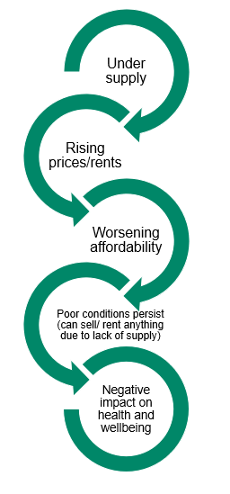 | 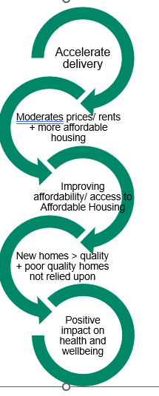
Source: AECOM
- The evidence in this report along with discussions with some of the Kent Housing Group members supports a simple ‘theory of change’ which links the Strategy themes. Whilst other factors play a role and some problems are likely to persist even if reduced, our hypothesis suggests that the delivery of new homes, with infrastructure alongside, will improve housing outcomes in Kent and Medway. This will provide more Affordable Housing, increase the stock of market and affordable homes that are in a good condition and provide improved safety and security to residents with knock on benefits in terms of health and wellbeing.

Questions for Stakeholders
- Does the evidence fit with your experience of housing issues in Kent and Medway? Recap:
  - Affordability – buying and renting remains unaffordable to a substantial proportion of households.
  - Affordable housing needs – far outweigh number of affordable homes delivered each year; private rented sector playing a significant role in meeting needs.
  - Homelessness and use of temporary accommodation remains persistently high – knock on impact on health and wellbeing and costs to local authorities.
  - Housing conditions – likely to be large number of properties with poor conditions, particularly in private rented sector, partly a function of affordability pressures and lack of Affordable Housing.
  - Health/wellbeing impacts – are very complex but housing factors such as cold homes/fuel poverty, overcrowding and older people in unsuitable accommodation provide clear link between housing and health.
  - Delivery issues – delivery picked up over last 5 years but still well below planned levels, knock on limit on the amount of Affordable Housing that can be secured.
- Can you add any further evidence or insight to support the findings (or challenge the findings)? Key data gaps include:
  - Local data on housing conditions
  - New build homes built to accessible and adaptable building regulations standards
  - Your own/ your organisation’s experience (even if qualitative or anecdotal) of the issues/ challenges
- Is there anything missing that is key to the evidence base for the Housing Strategy?
- Are the 5 themes still relevant?:
  - Affordability
  - Safety
  - Health and wellbeing
  - Accelerating delivery
  - Infrastructure first
- If not, what would you add/ remove or change?
- Are there any actions that you feel the Strategy should promote?

Introduction
  - The Kent and Medway Housing Strategy runs from 2020-2025 and is the 4th consecutive strategy which provides the strategic direction for housing in the County. The Strategy reflects the key issues and challenges and takes up opportunities to deliver housing ambitions locally and particularly those which are shared across Kent and Medway.
  - The Strategy has proven a valuable document – and the process in producing it valuable in itself – in bringing together the County and Districts to develop a shared agenda. It is therefore important that the Strategy is refreshed to serve beyond 2025 and that the evidence underpinning the Strategy is reviewed as part of this process.

Objectives
  - The objectives of the evidence refresh are:
- To ensure that the Kent and Medway Housing Strategy is based on up to date evidence;
- To ensure that recent and emerging challenges and policy developments are reflected in the evidence base so that the Strategy remains credible and relevant;
- To continue to reflect the common themes across Kent and Medway and maintain the shared purpose of the local authorities which was developed during the Strategy process;
- To provide a concise summary of the evidence and challenges relating to the housing market and housing outcomes which can be used in the updated Housing Strategy document.

Strategy Themes
  - There are five themes in the existing Kent and Medway Housing Strategy:
- Affordability
- Health and Wellbeing
- Safer Homes
- Infrastructure First
- Accelerating Housing Delivery
  - Three of the themes represent challenges in current housing outcomes: affordability, safer homes and health and wellbeing.
  - The remaining two themes are related to the actions aimed at tackling these challenges: accelerating housing delivery and provide infrastructure alongside new housing.
  - In summary, the theory of change is that increased delivery of new homes with infrastructure alongside will improve housing outcomes in Kent and Medway. This will provide more affordable housing, increase the stock of homes in good condition, offer safety and security to residents and create knock-on benefits in terms of health and wellbeing.

Figure 1-1: Theory of Change in the Housing Market
Vicious Circle | Virtuous Circle
Source: AECOM

National Policy Context
  - The last Kent and Medway Housing Strategy was developed 5 years ago in an already challenging context in relation to the affordability of housing and availability of affordable homes, and an acute reminder of persistent problems in the condition and safety of the UK housing stock following the tragedy of the Grenfell Tower fire.
  - However, the previous strategy was developed before the COVID19 pandemic and the onset of political instability globally in both Ukraine and the Middle East. Indirectly, these events have impacted on the housing market and housing needs and on households more widely through increases in inflation and the cost of living. Continuing macro-economic challenges – limited economic growth nationally and high inflation compared to previous periods - have reduced the ability of Government and other public sector organisations to address challenges due to the pressures on public spending.
  - Despite unprecedented global events which have added further dimensions to the challenges in the housing sector, there remains broad political consensus at the national level on the need for increased housing supply and delivery of affordable housing. The election of a new Government in July 2024 reinforced the position of housing as a political priority in the UK. Initial announcements following the election included a commitment to deliver 1.5 million homes over 5 years (300,000 per annum) in England.
  - Proposed reforms to the National Planning Policy Framework (NPPF) were published on 30th July 2024. Consultation on the proposed changes ran until 24th September 2024. The key areas relevant to the Kent and Medway Housing Strategy include:
- A revised methodology for calculating housing needs at the local authority level which uses 0.8% of the existing stock as the starting point for the number of new homes needed each year, rather than household projections, and then uplifts this figure according to affordability pressures.
- Proposals to strengthen cross boundary planning and cooperation including through greater powers for combined authorities.
- A focus on the delivery of Social Rent within Affordable Housing and the requirement that planning policies should specify the minimum proportion of Social Rent homes required.
- The removal of the requirement that 10% of all housing on major sites should be delivered as affordable home ownership tenures and the removal of the requirement that a minimum of 25% of affordable housing units secured through developer contributions should be First Homes.
- Development delivered through Green Belt release to provide higher proportions of affordable housing (50%).
  - A Renters’ Rights Bill has been introduced to Parliament which will ban Section 21 ‘no-fault’ evictions and extend Awaab’s Law into the private rented sector, providing tenants with the power to challenge dangerous conditions. The Decent Homes Standard will be introduced to the private rented sector and homes in the private rented sector will need to meet minimum energy efficiency standards by 2030. This will be subject to further consultation.

Housing Trends in Kent & Medway
  - This section examines headline data on the broad trends in terms of population, households and homes in Kent and Medway. Kent and Medway are home to 1,855,844 people and 759,893 households. This accounts for 3.3% of the population and 3.2% of all households in England.
  - The population has grown by 7% over the last 10 years and by 18% over 20 years. There is considerable variation between authority areas with some populations growing more rapidly – notably Ashford, Dartford, Maidstone, Swale, and Tonbridge and Malling. In contrast, slower population growth has been recorded in Sevenoaks, Dover, Thanet and Tunbridge Wells.
  - Across Kent and Medway, population growth has been driven by the older population, particularly those aged 70-74, as the baby boom cohort ages. This is broadly consistent across the authority areas but with notable growth in younger age groups, including young children, in Dartford with much more limited growth in the older population. Further analysis of the growth of the older population is considered further in Section 6.
Table 2-1: Long term Population Change, Kent and Medway 2001-2021
 | 2001 | 2011 | 2021 | Change 10 years |  | Change 20 years
Ashford | 102,661 | 117,956 | 132,747 | 14,791 | 13% | 30,086 | 29%
Canterbury | 135,278 | 151,145 | 157,432 | 6,287 | 4% | 22,154 | 16%
Dartford | 85,911 | 97,365 | 116,753 | 19,388 | 20% | 30,842 | 36%
Dover | 104,566 | 111,674 | 116,410 | 4,736 | 4% | 11,844 | 11%
Folkestone & Hythe | 96,238 | 107,969 | 109,758 | 1,789 | 2% | 13,520 | 14%
Gravesham | 95,717 | 101,720 | 106,900 | 5,180 | 5% | 11,183 | 12%
Maidstone | 138,948 | 155,143 | 175,782 | 20,639 | 13% | 36,834 | 27%
Medway | 249,488 | 263,925 | 279,773 | 15,848 | 6% | 30,285 | 12%
Sevenoaks | 109,305 | 114,893 | 120,514 | 5,621 | 5% | 11,209 | 10%
Swale | 122,801 | 135,835 | 151,676 | 15,841 | 12% | 28,875 | 24%
Thanet | 126,702 | 134,186 | 140,587 | 6,401 | 5% | 13,885 | 11%
Tonbridge & Malling | 107,561 | 120,805 | 132,201 | 11,396 | 9% | 24,640 | 23%
Tunbridge Wells | 104,030 | 115,049 | 115,311 | 262 | 0% | 11,281 | 11%
Kent & Medway | 1,579,206 | 1,727,665 | 1,855,844 | 128,179 | 7% | 276,638 | 18%
Source: Census, AECOM calculations
  - Although the ageing of the population is a prominent trend across Kent and Medway, as a whole, Kent and Medway has a slightly higher proportion of children (aged 0-14) in its population (18.0%) when compared to the South East and England as a whole (17.4%). It remains a popular location for families with children. In the northern authority areas including Dartford, Gravesham and Medway, the proportion of children is higher than the Kent and Medway average. In contrast, Dover and Folkestone and Hythe have notably smaller proportions of children and below the South East and England average with Canterbury at just 14.6% with its demographics impacted by the large student population.
  - The pattern of household growth has been consistent with population growth across Kent and Medway i.e. 7% growth over 10 years and 18% growth over 20 years according to Census data. The pattern varies across the authorities with some authorities experiencing household growth rates higher than population growth rates, indicating falling household size, consistent with the ageing of the population e.g. in Dover, Folkestone and Hythe, Thanet and Tunbridge Wells. There are likely to be other factors driving this pattern, particularly in the coastal towns with younger single households present as well as a growing older population.
Table 2-2: Long Term Household Growth, Kent and Medway, 2001-2021
 | 2001 | 2011 | 2021 | Change 10 years |  | Change 20 years
Ashford | 41,450 | 47,787 | 53,586 | 5,799 | 12% | 12,136 | 29%
Canterbury | 55,584 | 60,771 | 63,794 | 3,023 | 5% | 8,210 | 15%
Dartford | 35,240 | 40,081 | 45,697 | 5,616 | 14% | 10,457 | 30%
Dover | 44,314 | 48,310 | 50,548 | 2,238 | 5% | 6,234 | 14%
Folkestone and Hythe | 41,155 | 47,379 | 48,336 | 957 | 2% | 7,181 | 17%
Gravesham | 38,266 | 40,431 | 41,722 | 1,291 | 3% | 3,456 | 9%
Maidstone | 56,454 | 63,447 | 71,207 | 7,760 | 12% | 14,753 | 26%
Medway | 99,566 | 106,209 | 111,459 | 5,250 | 5% | 11,893 | 12%
Sevenoaks | 44,364 | 47,020 | 49,014 | 1,994 | 4% | 4,650 | 10%
Swale | 49,257 | 55,585 | 60,495 | 4,910 | 9% | 11,238 | 23%
Thanet | 55,228 | 59,513 | 62,199 | 2,686 | 5% | 6,971 | 13%
Tonbridge and Malling | 42,736 | 48,140 | 53,573 | 5,433 | 11% | 10,837 | 25%
Tunbridge Wells | 42,695 | 47,174 | 48,223 | 1,049 | 2% | 5,528 | 13%
Kent & Medway | 646,309 | 711,847 | 759,853 | 48,006 | 7% | 113,544 | 18%
Source: Census, AECOM calculations
  - Census 2021 suggests that the dwelling stock across Kent and Medway grew by 9% over the last 10 years and 21% over the last 20 years. The latter suggests a rate of growth in the housing stock of more than 1% per annum, a benchmark which is typically considered a strong level of supply. There are currently 810,611 dwellings in Kent and Medway.
  - It is notable that some local authorities have experienced greater growth in the dwelling stock over the last 10 years, including Ashford, Dartford, Maidstone and Swale – each experiencing growth of 14-16% in their housing stock 2011-2021.
  - There is a discrepancy between the number of net additions to the dwelling stock in the 10 years (2011-2021) and the dwelling stock recorded in the Census 2021. For some authorities, the dwelling stock in 2021 is larger than expected when compared to the monitoring of new housing completions, conversions and permitted development. An element of this difference is explained by the counting of some caravans as permanent dwellings which may not be occupied as such. This issue has been raised by KHG with the ONS.
  - It is relevant to note that just over 6% of the dwelling stock in Kent and Medway is not usually occupied by a household. This means that at the time of the Census 2021, 6% of dwellings were not occupied. The proportion is consistent with England as a whole but has risen nationally from 4% in 2011. It is likely that increases in the number of second homes and holiday lets has impacted on this figure to some extent. The counting of some caravans as permanent dwellings may also account for some of the increase. The timing of Census 2021 during a period of Covid restrictions may also have impacted on the count as some single households formed ‘bubbles’ to avoid isolation and may have vacated their own homes temporarily. Students may have also returned to the family home to avoid isolation and whilst university courses were moved online.
Table 2-3: Long Term Dwelling Stock Change, Kent and Medway, 2001-2021
 | 2001 | 2011 | 2021 | Change 10 years |  | Change 20 years
Ashford | 42,923 | 49,747 | 56,653 | 6,906 | 14% | 13,730 | 32%
Canterbury | 57,827 | 63,859 | 67,946 | 4,087 | 6% | 10,119 | 17%
Dartford | 35,998 | 41,220 | 47,921 | 6,701 | 16% | 11,923 | 33%
Dover | 46,265 | 51,453 | 54,720 | 3,267 | 6% | 8,455 | 18%
Folkestone and Hythe | 44,322 | 49,568 | 53,108 | 3,540 | 7% | 8,786 | 20%
Gravesham | 39,110 | 41,699 | 44,071 | 2,372 | 6% | 4,961 | 13%
Maidstone | 58,019 | 65,526 | 75,558 | 10,032 | 15% | 17,539 | 30%
Medway | 102,578 | 110,107 | 117,443 | 7,336 | 7% | 14,865 | 14%
Sevenoaks | 45,585 | 48,376 | 51,605 | 3,229 | 7% | 6,020 | 13%
Swale | 51,078 | 57,989 | 66,200 | 8,211 | 14% | 15,122 | 30%
Thanet | 59,036 | 64,998 | 68,964 | 3,966 | 6% | 9,928 | 17%
Tonbridge and Malling | 43,856 | 49,972 | 55,487 | 5,515 | 11% | 11,631 | 27%
Tunbridge Wells | 43,786 | 48,922 | 50,935 | 2,013 | 4% | 7,149 | 16%
Kent & Medway | 670,383 | 743,436 | 810,611 | 67,175 | 9% | 140,228 | 21%
Source: Census, AECOM calculations

Implications for the Strategy
  - The long term rise in population and growth in the number of households creates demand and need for housing. It is important to note that household growth is not the only driver of demand for homes, with growth in incomes and wealth also driving greater demand either for the quantity or size of homes.
  - The growth in the dwelling stock has been broadly in line with the growth in the household population which is likely to have moderated price rises compared to what they might have been. However, household size in Kent and Medway rose slightly between 2011 and 2021 which may indicate some suppression of household formation due to persistent affordability challenges. Whilst the growth in the dwelling stock has been in line with the growth in households, the vacancy rate of dwellings increased over the period 2011-2021 indicating that not all dwellings are directly meeting household needs (e.g. some are second homes or holiday lets).
  - The growth in the number of people and households in Kent and Medway confirms the need to focus on the delivery of new homes and associated supporting infrastructure. These are two of the existing themes in the Strategy and appear to remain important to the future Strategy.

Housing Market Change
  - House prices provide an indication of the level of demand for homes within an area. The relationship between house prices and incomes determines whether housing is affordable to local households and, to a large extent, what tenure, type and size of home they occupy. Changes in affordability over time can indicate pressures in the housing market. As such, it is useful for the evidence base for Local Plans and strategies to examine trends in prices and consider what this reveals about the local housing market.
  - This section examines headline indicators in the housing market in Kent and Medway including prices, rents and earnings and how these impact on affordability for households.

House Prices and Affordability
  - Average (median) house prices ranged from £300,000 in Dover to £465,000 in Sevenoaks at the end of 2023. Over the 5 year period to the end of (Dec) 2023, average prices increased by 15-30% across the Kent and Medway authorities. The fastest price growth over the period was in Thanet District (30%), having had the lowest average prices amongst all of the authority areas in 2019 and may reflect the impact of the long term regeneration activities in the district. The lowest price growth over the 5 years was in Maidstone (15%), albeit average prices in 2023 at £360,000 remained high.
Figure 3-1: Median House Prices ££, Kent and Medway authorities, South East and England 1997-2023
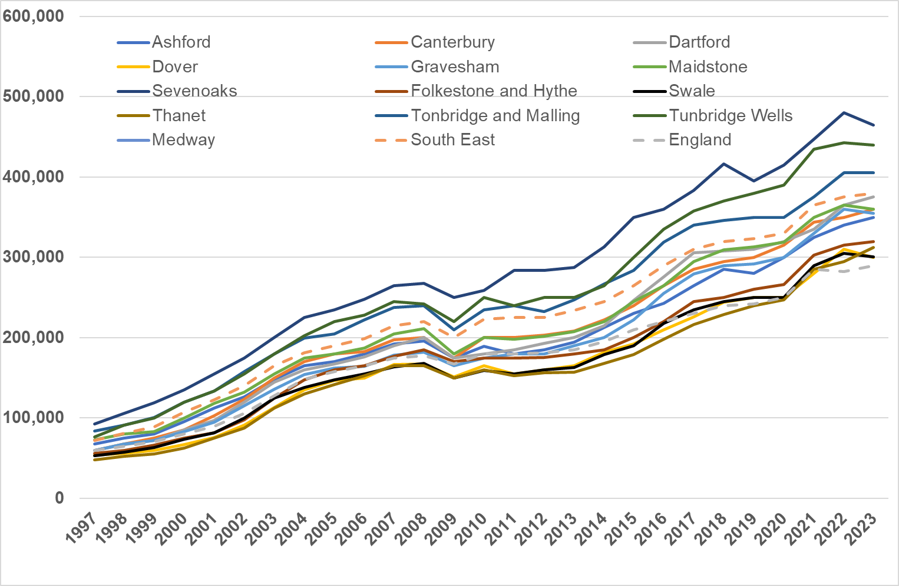
Source: ONS
Figure 3-2: Lower Quartile Prices in the Kent and Medway authorities, South East, England 1995-2023
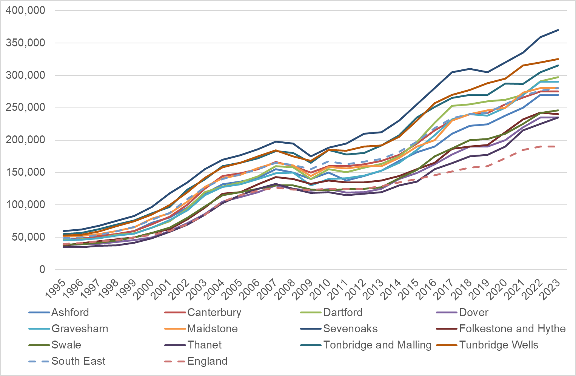
Source: ONS
  - Lower Quartile prices provide an indication of the cost of entry level homes. This indicator is useful because it provides an indication of the likely price of housing for newly forming and first-time buyer households.
  - Lower quartile prices range from £235,000 in Dover, with similarly lower prices in Folkestone and Hythe, to £370,000 in Sevenoaks. Lower quartile prices have risen slightly less rapidly than median average prices in most authorities over the last 5 years. The lowest growth rate (13%) was in Tunbridge Wells but will relatively high LQ prices remaining in 2023 at £325,000. The highest growth rate was in Thanet at 32% but, as with median prices, form a relatively low base and remaining at £235,000 in 2023. There is no consistent pattern to the price rises (e.g. faster growth in the cheaper areas and vice versa). Indeed, Sevenoaks LQ prices rose by 21% over 5 years from £305,000 in 2019 to £370,000 – starting and remaining highest price area for lower quartile properties in Kent and Medway.
  - It is useful to compare earnings growth (median gross annual earnings) to house price growth over the last 5 years. Figure 3-3 presents median earnings for individuals across the Kent and Medway authorities. It is important to keep in mind that this is not household income. Household incomes will be different because some households contain two people earning and may be made up of other sources of income (e.g. from pensions etc). However, median earnings provide a useful indication of how earnings have changed over time and whether they have grown in line with average house prices or not.
  - Median earnings for workers in the Kent and Medway authorities range from £29,300 in Thanet in 2023 to £39,000 in Gravesham. Earnings growth has been substantially lower than house price growth across Kent and Medway, ranging from just 3% in Maidstone over 5 years to 24% in Folkestone and Hythe. In Folkestone and Hythe, Dover and Medway, median earnings growth has been higher or in line with median house price growth over the last 5 years.
  - In contrast, in Ashford, Maidstone and Sevenoaks, median earnings growth has been substantially lower than median house price growth over the last 5 years.
Figure 3-3: Median Gross Workplace Earnings in the Kent and Medway authorities 1997-2023
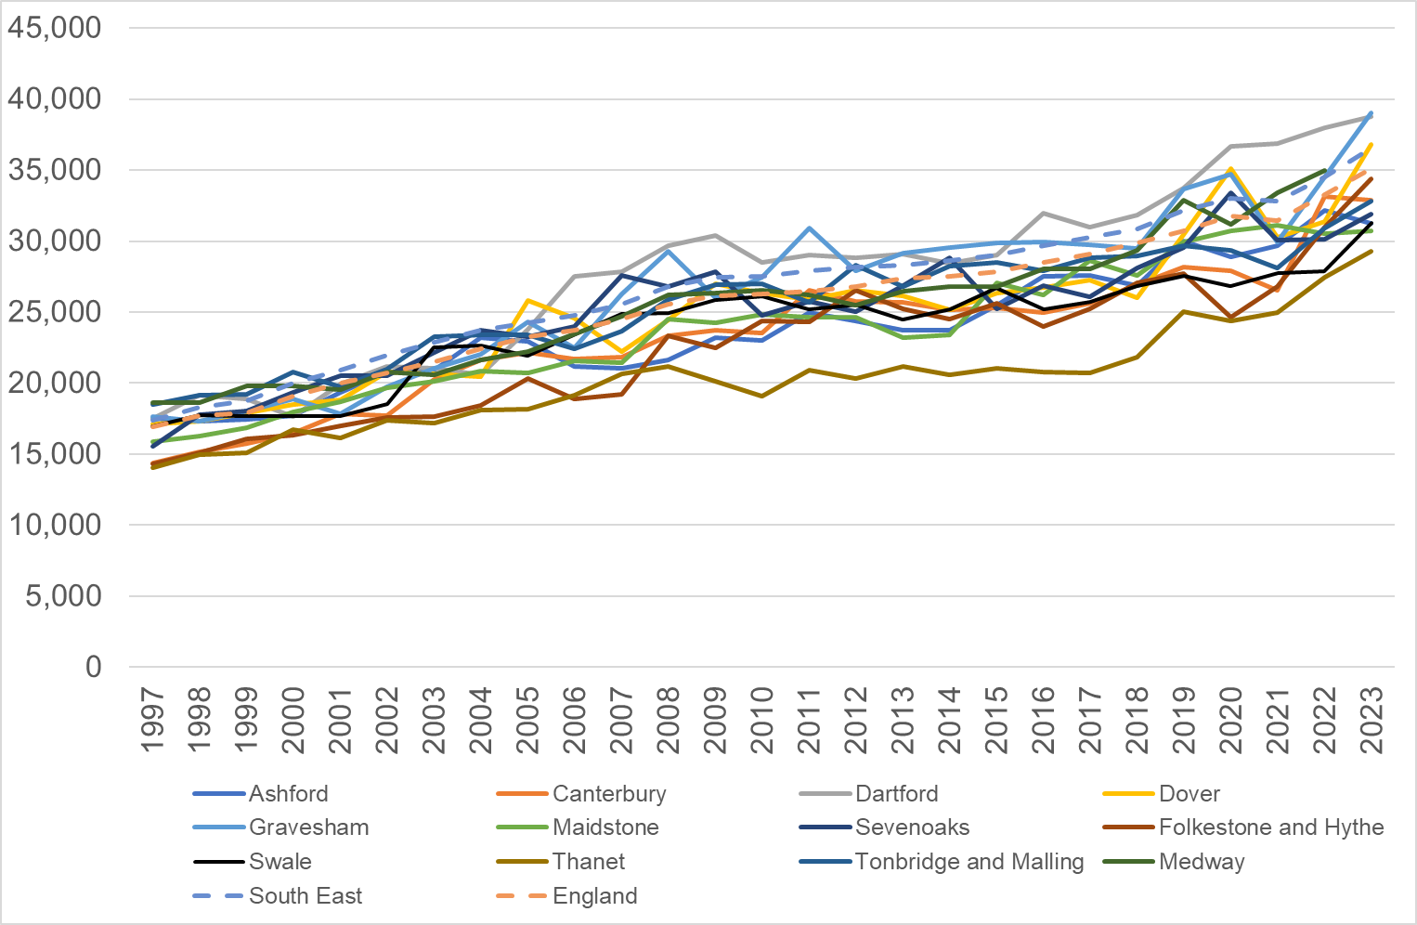
Source: ONS
  - The relationship between median house prices and median earnings provides an indication of affordability in each authority area and how this has changed over time. Figure 3-4 presents the ratio of median house prices to median earnings for each authority, the South East and England.
  - Affordability is worst in Sevenoaks where median house prices are more than 14 times median earnings. Even the most affordable authority area (Dover) has median house prices that are more than 8 times median earnings. This pattern is reflective of the long term rise in prices and more limited increases in earnings. The range of affordability ratios in Kent and Medway is broadly in line with the South East region but substantially higher (less affordable) than England as a whole.
  - In 2023, affordability has improved or remained stable (compared to 5 years ago) in Dover, Folkestone and Hythe and Tunbridge Wells. There was only a marginal decline in Medway but in all of the other authorities, the affordability ratio worsened with the greatest decline in affordability in Ashford, Maidstone, Sevenoaks and Thanet. There are likely to be different drivers in each authority with some experiencing rapid house price growth and others experiencing limited earnings growth. In summary, the last 5 years shows a mixed pattern in terms of affordability with some improvement in some authorities and continued declines in others. Overall, affordability remains poor – the small improvements that there have been, have not yet been sufficient to bring affordability to the more reasonable levels seen in earlier decades. Median househ prices are more than 8 times median earnings in all of the Kent and Medway authorities which means that many working households will not be able to secure a mortgage.
Figure 3-4 Median House Prices to Median Earnings Affordability Ratio, Kent and Medway authorities, South East and England.
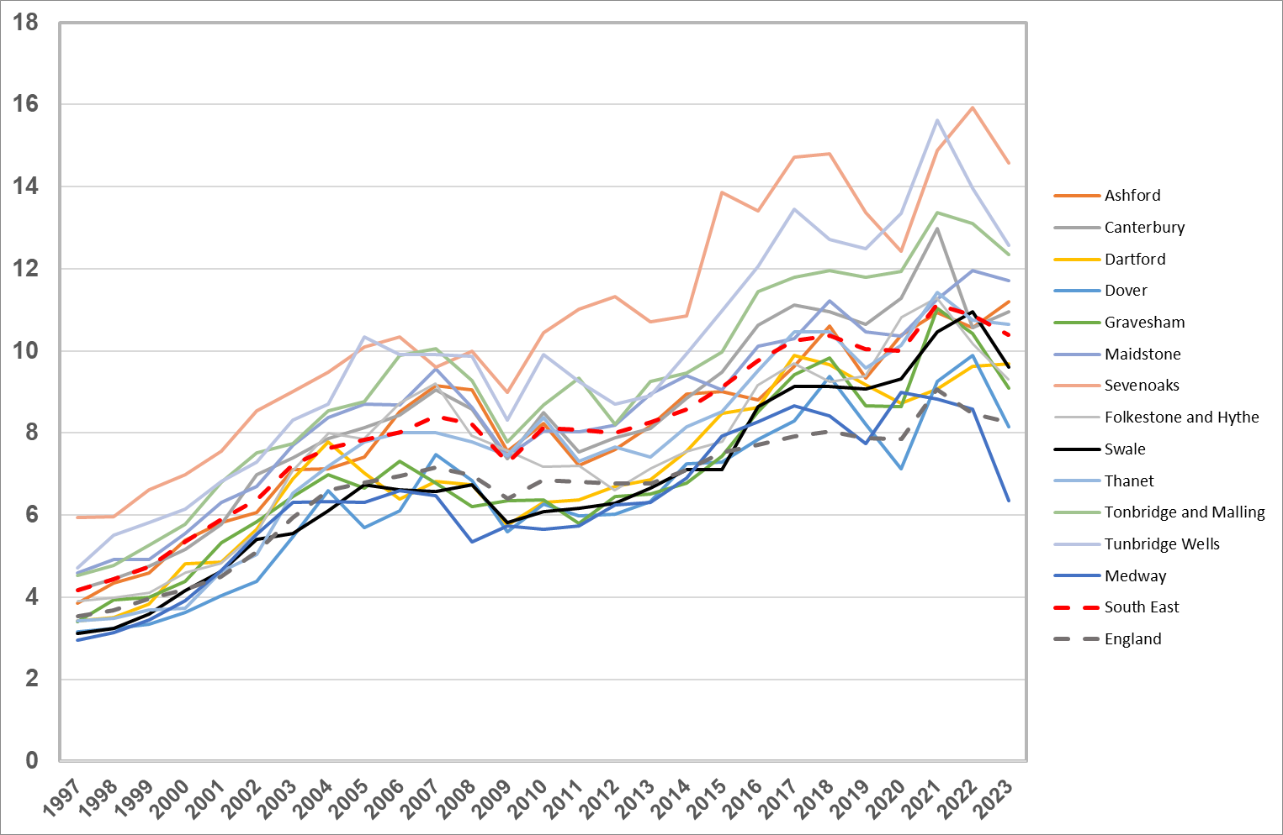
Source: ONS

Private Rents and Affordability
  - Across Kent and Medway as a whole, 19.2% of households (145,566 households) live in the private rented sector (including those living rent free) in 2021. The number of households living in the sector has increased by 14.2% since 2011 and this is likely to have been driven in large part by declining affordability of home ownership over this period.
  - Average (median) rents range from £775 per month to £1,395 per month. The cheapest average rents are found in Dover, Folkestone and Thanet with substantially higher rental prices in Sevenoaks, Dartford and Tunbridge Wells.
  - As with the pattern of price growth, rental prices have generally risen faster than median earnings. There are some exceptions to this with earnings increasing more than rental increases in Gravesham and Medway.
  - However, the final column in Figure 3-5 illustrates the proportion of median monthly earnings spent on median rents in each authority area. Typically, an affordable threshold is considered to be 30% of household income spent on rent. This is not directly applicable here because the data relates to individual earnings rather than household incomes. However, households with a single earner on median earnings will need to spend more than 30% of their earnings on rent in most of the Kent and Medway authorities (with the exception of Dover and Folkestone and Hythe). In contrast, in Sevenoaks, households would need to spend 53% of their median earnings on the average rented property.
Figure 3-5: Median Rents, Last 5 Years, Proportion of Median Earnings Spent on Rent, Kent and Medway Authorities
 | 2019 | 2020 | 2021 | 2022 | 2023 | Change 5 Years | % change 5 years | % Median earnings spent on rent
Ashford | £795 | £800 | £850 | £900 | £950 | £155 | 19% | 36%
Canterbury | £800 | £775 | £875 | £875 | £950 | £150 | 19% | 35%
Dartford | £950 | £975 | £1,025 | £1,125 | £1,200 | £250 | 26% | 37%
Dover | £650 | £700 | £700 | £725 | £775 | £125 | 19% | 25%
Folkestone and Hythe | £595 | £641 | £700 | £650 | £775 | £180 | 30% | 27%
Gravesham | £875 | £875 | £900 | £935 | £1,000 | £125 | 14% | 31%
Maidstone | £850 | £850 | £850 | £875 | £950 | £100 | 12% | 37%
Sevenoaks | £1,200 | £1,175 | £1,300 | £1,343 | £1,395 | £195 | 16% | 53%
Swale | £775 | £800 | £840 | £850 | £900 | £125 | 16% | 35%
Thanet | £675 | £675 | £725 | £750 | £800 | £125 | 19% | 33%
Tonbridge and Malling | £995 | £1,000 | £1,030 | £1,100 | £1,200 | £205 | 21% | 44%
Tunbridge Wells | £950 | £985 | £1,000 | £1,003 | £1,100 | £150 | 16% | 38%
Medway | £800 | £800 | £825 | £850 | £900 | £100 | 13% | 31%
SOUTH EAST | £895 | £895 | £925 | £975 | £1,050 | £155 | 17% | 34%
ENGLAND | £700 | £725 | £755 | £800 | £850 | £150 | 21% | 29%
Source: ONS Private Rental Market Series, AECOM calculations
  - Figure 3-6 provides data on lower quartile rents – the price of the cheapest 25% of properties on the market each year. Lower quartile rents have increased over the last 5 years in all authority areas, consistent with the South East and England. However, it is a mixed picture across the authorities in terms of whether price rises have outstripped growth in lower quartile earnings.
  - Lower Quartile (LQ) earnings give an indication of the incomes of households on lower incomes, albeit they do not factor in benefits if they are entitled to receive them. Whilst not perfect, it allows for comparison of affordability over time and between authorities on a consistent basis. LQ earnings range from £22,200 in Swale to £29,100 in Dartford. LQ earnings are higher in Dartford and Gravesham, likely due to proximity to London and the spill out of some higher paid jobs to these authority areas. The lowest LQ earnings are in Swale and Thanet but the other Kent and Medway authorities are not substantially higher (c.£24-25k).
  - Lower quartile rents have grown faster than lower quartile earnings in Ashford, Canterbury, Swale, Thanet, Tunbridge Wells and Tonbridge and Malling. In all of the other authorities, earnings appear to have increased faster than the increase in LQ rents. Over the last 5 years therefore, affordability of lower quartile priced rented properties has improved slightly across most of the Kent and Medway authorities. However, this does not mean that these rents are affordable. Where households rely on a single lower quartile earner, they are likely to spend substantial proportions of their income on rent (with the exception of Dover District and Folkestone and Hythe which appear more affordable). Again, this does not take account of any additional support households may receive through benefits.

Figure 3-6: Lower Quartile Rents Over Last 5 Years and Proportion of LQ Earnings spent on Rent
 | 2019 | 2020 | 2021 | 2022 | 2023 | Change 5 Years | % change 5 years | % LQ earnings spent on rent
Ashford | £675 | £695 | £750 | £750 | £775 | £100 | 15% | 39%
Canterbury | £420 | £425 | £570 | £550 | £655 | £235 | 56% | 33%
Dartford | £825 | £825 | £866 | £925 | £950 | £125 | 15% | 39%
Dover | £525 | £575 | £575 | £575 | £604 | £79 | 15% | 26%
Folkestone and Hythe | £495 | £525 | £575 | £545 | £600 | £105 | 21% | 28%
Gravesham | £750 | £725 | £750 | £775 | £825 | £75 | 10% | 34%
Maidstone | £725 | £725 | £700 | £700 | £760 | £35 | 5% | 37%
Sevenoaks | £975 | £925 | £1,030 | £1,075 | £1,100 | £125 | 13% | 51%
Swale | £665 | £710 | £745 | £750 | £800 | £135 | 20% | 42%
Thanet | £550 | £550 | £585 | £620 | £662 | £112 | 20% | 36%
Tonbridge and Malling | £850 | £875 | £875 | £900 | £950 | £100 | 12% | 44%
Tunbridge Wells | £775 | £795 | £800 | £825 | £875 | £100 | 13% | 40%
Medway UA | £650 | £675 | £695 | £705 | £750 | £100 | 15% | 34%
SOUTH EAST | £725 | £735 | £750 | £800 | £850 | £125 | 17% | 38%
ENGLAND | £550 | £550 | £585 | £800 | £650 | £100 | 18% | 30%
Source: ONS Private Rental Market Series, AECOM calculations

  - Local Housing Allowance (maximum housing benefit that can be claimed) remained static between 2020/21 and 2023/24 and did not keep up with the increase in private rents across Kent and Medway. This means that housing benefit was insufficient to cover lower quartile rents and households supported by housing benefit needed to find additional funds to cover their rents (from earnings or other benefits) or find themselves struggling to pay their rent and building up arrears. LHA rates have now increased for 2024/25 to a level close to the LQ rental rates seen in 2023/24.
  - The poor affordability of even the cheapest rental properties in the private rented sector for those reliant on housing benefit directly has contributed to households becoming homeless and requiring assistance from the Kent and Medway Councils, including through the provision of temporary accommodation. The increase in the LHA rate in the last year may ease affordability pressures for some households and could help prevent some homelessness incidences in the future but there are likely to remain gaps for households affected by benefit caps who cannot claim the full LHA rate.

Implications for Strategy
  - The affordability of housing to buy or rent in Kent and Medway remains poor compared to historic levels despite minor improvements in some local authorities on some measures over the last 5 years. Affordability is one of the 5 themes in the Kent and Medway Strategy. The latest evidence suggests that the affordability challenge remains albeit there are substantial variations in affordability across the sub region with notable poor affordability in Sevenoaks and better affordability in Dover and Folkestone and Hythe. Affordability to buy is worst in Sevenoaks where median house prices are more than 14 times median earnings. Even the most affordable authority area (Dover) has median house prices that are more than 8 times median earnings.
  - A similar pattern is seen with the affordability to rent in the market with households needing to spend much greater proportions of their income or earnings on rent in the West Kent authorities compared to some of those in East Kent. Lower quartile private rents have not been covered in full by the the Local Housing Allowances rates (housing benefit) in recent years which has generated affordability problems for those reliant on housing benefit and contributes to homelessness levels across Kent and Medway (discussed in the next section of this report). The recent uplift to the LHA rates suggests that is currently covers lower quartile rents across much of Kent and Medway but it is uncertain whether this will be maintained.

Need for Affordable Housing
  - Given the price of housing to buy or rent within Kent and Medway and the pattern of poor affordability in many parts of the sub-region, a proportion of households are unable to afford to buy or rent in the market. These households need some form of subsidy to afford the housing they need – either support through housing benefit and/or subsidised housing i.e. Affordable Housing.
  - The definition of Affordable Housing is set out in the NPPF 2023 (Annex 2) as ‘Housing for sale or rent, for those whose needs are not met by the market…’ This report refers to Affordable Housing, with capital letters, to denote the specific tenures that are classified as affordable in the current NPPF (Annex 2). A relatively less expensive home for market sale may be affordable but it is not a form of Affordable Housing. A range of affordable home ownership opportunities are included in the Government’s definition of Affordable Housing, to meet the needs of those aspiring to own a home.
  - This section examines headline indicators on the need for Affordable Housing across Kent and Medway. This study does not undertake an Affordable Housing Need Assessment in line with National Planning Practice Guidance. This is the role of individual local planning and housing authorities and usually undertaken as part of a Local Housing Need Assessment, Strategic Housing Market Assessment of Housing and Economic Needs Assessment. This report draws on the studies undertaken by authorities across Kent and Medway to draw together a collective picture of needs across the sub-region.
  - This section also draws on up to date insight from the housing registers of the Kent and Medway authorities.

Evidence of Affordable Housing Needs
  - A review of all of the available and most up to date Local Housing Need Assessments across Kent and Medway allows a headline aggregation of the scale of need for Affordable Housing in the sub-region. It is important to stress that each study (see Appendix B) has been undertaken at different times, by different consultants and as such, assumptions vary. For example, in both Medway and Tunbridge Wells, the studies assume that Affordable Housing needs backlogs are addressed over 10 years. This may be a shorter period than in other assessments and hence results in a higher annualised need for Affordable Housing than if a longer period was used. Nevertheless, Figure 4-1 provides a broad indication of the scale of need across Kent and Medway. It should not be used to directly compare needs across individual authorities due to the different assumptions used in different areas.
  - Table 4-1 suggests that there is need for almost 5,000 Affordable Homes each year across Kent and Medway to meet the needs of households who are unable to afford to buy or rent in the market. Net additions to the housing stock overall over the last 5 years have averaged 7,277 per annum. This suggests that identified Affordable Housing needs would equate to two thirds (67%) of total housing supply if they were to be met in full. In the last 5 years, delivery of Affordable Housing in Kent and Medway has averaged 1,522 per annum – equating to around one third of what is likely to be needed (see Table 4-2). This is likely to be reflected in persistently higher numbers of local authority waiting lists (see below) and many households staying in or being placed in private rented accommodation, often supported by housing benefit.
  - Our headline review of documents only identified three studies where there was a clear distinction between the need for Social/Affordable Rented housing and affordable home ownership. In most studies, the two groups who need Affordable Housing (those who need rented and those that can afford to rent buy cannot afford to buy) have been grouped together, or it is not easy to separate them out.
Table 4-1: Headline Affordable Housing Need, Kent and Medway Based on Local Authority LHNAs/SHMAs
 | Social/Affordable Rent | Affordable Home Ownership | Total per annum
Ashford |  |  | 335
Canterbury | 308 | 156 | 464
Dartford |  |  | 263
Dover |  |  | 167
Folkestone and Hythe |  |  | 139
Gravesham | ~ | ~ | ~
Maidstone | 422 | 137 | 559
Sevenoaks |  |  | 423
Swale |  |  | 287
Thanet |  |  | 397
Tonbridge and Malling |  |  | 283
Tunbridge Wells | 323 | 347 | 670
Medway |  |  | 870
Kent + Medway |  |  | 4,857
Source: Appendix B Headline Summary of Local Authority Assessments
Table 4-2: Annual Average Net Additions of Market and Affordable Housing, Last 5 Years and Since 2011
 | 2019-20 to 2023-24 |  | 2011-12 to 2023-24
 | Market | Affordable | Market | Affordable
Ashford | 480 | 104 | 1,062 | 244
Canterbury | 350 | 110 | 800 | 150
Dartford | 478 | 168 | 1,386 | 330
Dover | 366 | 42 | 726 | 116
Folkestone and Hythe | 246 | 40 | 466 | 58
Gravesham | 176 | 100 | 332 | 156
Maidstone | 574 | 544 | 1,224 | 1,140
Sevenoaks | 118 | 16 | 296 | 42
Swale | 406 | 74 | 834 | 166
Thanet | 222 | 92 | 414 | 140
Tonbridge and Malling | 246 | 64 | 904 | 202
Tunbridge Wells | 352 | 54 | 554 | 90
Medway | 650 | 114 | 1,194 | 294
Kent + Medway | 4,664 | 1,522 | 10,192 | 3,128
Source: MHCLG Housing Statistics – Net Additions Table 123

Indicators of Acute Housing Need
  - There are currently (as at mid 2024) 17,608 households on local authority housing waiting lists (also known as housing registers) across Kent and Medway (Table 4-3). This equates to 2.3% of all households across Kent and Medway.
  - Different local authorities maintain their waiting lists in different ways and so the figures are not always directly comparable but provide a broad indication of the scale of need across Kent and Medway for the purposes of this study. Varying levels of applicants across the authorities also reflects the tendency for lower income households to gravitate towards areas where they are more likely to be able to secure affordable housing. This often means that households in need (or newly forming households) in more rural areas will move to towns and cities where there is a larger private rented sector or greater availability of Affordable Housing. Over time, this can result in larger waiting lists in the urban and coastal areas and smaller lists in the more rural areas or places with more expensive housing.
  - This figure does not represent net need for Affordable Housing as some of these households already have Social/Affordable Rented homes but need to move to a bigger, smaller or more suitable property. Some households on waiting lists may be able to find accommodation in the private rented sector, with the support of housing benefit and the local authority housing team’s support. There is a debate about whether this would provide sufficient security of tenure for some households and a higher proportion of private rented properties are in a poor state of condition compared to the Social/Affordable Housing sector. Nevertheless, it is important to acknowledge that the private rented sector meets a substantial proportion of housing needs which would otherwise require the provision of some form of Affordable Housing.
Table 4-3: Households on Waiting Lists Across Kent and Medway, 2024
Local Authority | Households on the waiting list (all bands)
Ashford | 1,731
Canterbury | 1,025
Dartford | 1,344
Dover | 2,010
Folkestone & Hythe | 1,384
Gravesham | 875
Maidstone | 1,240
Sevenoaks | 989
Swale | 1,814
Thanet | 1,480
Tonbridge and Malling | 246
Tunbridge Wells | 665
Medway | 2,805
Total | 17,608
Source: Kent HomeChoice
  - Table 4-4 shows the current tenure of the vast majority of households on the waiting lists in Kent and Medway. There are a range of other ‘tenures’ listed including ‘sheltered housing’ and ‘employer provided’ but these account for less than 1% of applicants across all authorities. The majority of applicants live in existing Council or housing association housing (social or affordable rent) (35%) or live in the private rented sector (30%). A substantial proportion live with friends and family (16%) and, across Kent and Medway as a whole, 12% of households on the waiting list live in temporary accommodation.

Table 4-4: Main Tenures of Households on Waiting Lists, 2024
 | Council or housing association tenant | Renting from a private landlord (inc lodgers) | Living with family/ friends | Temporary accommodation/ homeless
Ashford | 36% | 22% | 25% | 11%
Canterbury | 43% | 31% | 9% | 8%
Dartford | 29% | 28% | 22% | 16%
Dover | 32% | 40% | 12% | 11%
Folkestone & Hythe | 31% | 43% | 13% | 7%
Gravesham | 37% | 23% | 17% | 15%
Maidstone | 41% | 21% | 14% | 16%
Medway | 46% | 25% | 11% | 14%
Sevenoaks | 40% | 23% | 22% | 9%
Swale | 28% | 30% | 21% | 15%
Thanet | 22% | 43% | 18% | 12%
Tonbridge & Malling | 49% | 18% | 15% | 12%
Tunbridge Wells | 37% | 24% | 16% | 12%
Kent & Medway | 35% | 30% | 16% | 12%
Source: Kent HomeChoice
  - This data underlines that a key source of ‘demand’ for Social/Affordable Rented housing comes from households who are living in insecure accommodation in the private rented sector or temporary housing. A proportion of these households will be struggling to pay their rent (even with housing benefit), as assessed by the KHG dashboard data which shows the shortfall between LHA levels and LQ private rents across property sizes.
  - AECOM has analysed the available income data from the Kent Homechoice waiting list (the aggregation of all of the local authority waiting list data across Kent).
- Most households on the waiting lists across Kent and Medway are reliant on benefits to some extent (84%). 40% of these households have some income from earnings. For households with income from earnings, their average income (including the benefits they receive) is £2,250 per month. This equates to £27,000 each year and is consistent with the level of LQ earnings across Kent, albeit this figure includes earnings and any benefits received.
- 60% of households on the waiting list have no income from employment. This figure includes older households who will receive the state pension (and potentially other pension income) as well as households headed by people who are out of work or unable to work. Where households are wholly reliant on benefits, the maximum total that can be claimed is just over £22,000 for single parent or couple households. The maximum for single people is £14,750 (see Table 4-5). This means that those households on the waiting list who are wholly reliant on benefits will have incomes that are lower than LQ earnings across Kent and Medway. This is particularly true for applicants under the age of 35 who are only be able to claim housing benefit to cover the cost of a room in a shared housing and thus have much reduced incomes from benefits.
  - It is important to stress that income data included in local authority waiting lists is often patchy and has not been verified. Nonetheless, the figures appear reasonable and are in line with other waiting list analyses the team has undertaken. Analysis is complicated by the interaction of earnings and benefits. However, households on the waiting list appear to have very low incomes, highlighting the challenge in finding affordable and suitable accommodation to meet their needs.
Table 4-5: Benefit Cap
The benefit cap is a limit on the total amount of benefit anyone can receive. It applies to most people aged 16 or over who have not reached State Pension age.
Outside Greater London (including Kent and Medway) the overall benefit cap is:
Couple (with or without children): £423.46 per week, equating to £22,019.92 per annum
Single parent (including children): £423.46 per week, equating to £22,019.92 per annum
Single adult (no children): £283.72 per week, equating to £14,753.44 per annum
Households who are reliant on benefits and have no other income or earnings need to cover all of their living costs within these amounts.
Note that there is also a separate limit on the amount of child benefit that a household can claim, regardless of whether their overall benefits are capped. Households are limited to claims for two children (excluding those children born before 2017).
Source: gov.uk/benefit-cap/benefit-cap-amounts

Supply of Affordable Housing for Rent
  - There were 4,432 lettings of Social/Affordable Rented homes across Kent and Medway in the year 2023-2024. The majority of lettings were comprised of existing Social/Affordable Rented homes which became available for re-let but a substantial number (at least 777), equating to at least 17.5% of lettings in the year, were new build properties. This underlines the importance of new build Affordable Housing supply to meeting needs across Kent and Medway. The true proportion is likely to be higher as three authorities did not provide separate data for new build lettings.
Table 4-6: Lettings of Social/Affordable Rented Housing 2023/24
LA | New build lettings | Relets | Total
Ashford | 22 | 137 | 159
Canterbury |  |  | 479
Dartford | 87 | 274 | 361
Dover | 102 | 240 | 342
Folkestone & Hythe | 0 | 226 | 226
Gravesham | 307 | 62 | 369
Maidstone | 173 | 393 | 566
Medway | 0 | 587 | 587
Sevenoaks | 4 | 220 | 224
Swale |  |  | 423
Thanet |  |  | 353
Tonbridge and Malling | 21 | 54 | 75
Tunbridge Wells | 61 | 207 | 268
Total | 777 | 2,400 | 4,432
Source: Kent Homechoice
  - Lettings by size by local authority are given in the Table 4-7. For Kent and Medway as a whole (not including Gravesham, for which no breakdown was available) the proportions are as follows:
- 2% studio
- 42% 1 bed
- 40% 2 bed
- 15% 3 bed
- 2% 4+ bed
  - The vast majority of lettings are smaller properties 1-2 bedroom. Just 17% of properties available for letting over the year were 3 bedroom or larger. Whilst there is some variation in the pattern between local authorities, smaller properties dominate the available lettings. This is likely to present challenges to the local authorities in accommodating larger family households, including multi-generational households which have a higher prevalence in some ethnic minority communities and this is common issue across most of the local authorities that the AECOM team work with.
Table 4-7: Size Mix of Lettings
 | Studio | 1 bed | 2 bed | 3 bed | 4 bed | 5 bed
Ashford | 0 | 70 | 63 | 22 | 4 | 0
Canterbury | 31 | 225 | 178 | 42 | 3 | 0
Dartford | 4 | 174 | 131 | 49 | 3 | 0
Dover | 6 | 74 | 187 | 62 | 10 | 3
Folkestone & Hythe | 20 | 90 | 78 | 34 | 4 | 0
Gravesham | 0 | 0 | 0 | 0 | 0 | 0
Maidstone | 0 | 233 | 241 | 76 | 16 | 0
Sevenoaks | 0 | 118 | 68 | 36 | 2 | 0
Swale | 0 | 174 | 168 | 75 | 6 | 0
Thanet | 0 | 105 | 171 | 61 | 4 | 0
Tonbridge & Malling | 12 | 18 | 33 | 23 | 0 | 1
Tunbridge Wells | 0 | 121 | 107 | 37 | 3 | 0
Medway UA | 0 | 294 | 194 | 94 | 5 | 0
Kent & Medway | 73 | 1,696 | 1,619 | 611 | 60 | 4
Kent & Medway % | 2% | 42% | 40% | 15% | 1% | 0%
Source: Kent Homechoice
  - [Awaiting data on Gypsy and Traveller needs assessment and need for pitches across Kent]. Medway’s assessment identified 31 households needing pitches over the plan period 2022-2041 based on the planning definition. A further 10-15 undetermined (based on modelled needs) and 10 do not meet planning definition.

Homelessness and Temporary Accommodation
  - The most acute indicator of housing need within Kent and Medway, and other areas of the country, is homelessness. In the context of rising prices and rents, poor affordability and a limited supply of Affordable Housing, some households find themselves living in very insecure accommodation in the private rented sector and other insecure forms of housing, unable to afford rising rents, or living with friends/family and often subject to a breakdown in relationships which leads them to become at risk of homelessness.
  - There are very specific criteria in the Housing Act for identifying households who are homeless or at risk of becoming homeless. These households are ‘owed a duty’ under the Housing Act which means the local authorities must either take action to prevent the household becoming homeless, or provide direct relief if they are already homeless, i.e. provide them with accommodation.
  - In 2022-23 (latest full year data), 9,152 households in Kent and Medway became homeless (Table 4-8). The number of households defined as homeless (owed a prevention or relief duty) fell across the sub-region over the 5 year period by 9%. There were falls in most of the Kent and Medway authorities with significant improvements in Thanet, Dover, Sevenoaks, Canterbury and Ashford. Falls on this measure are often due to actions taken by local authority housing officers to prevent homelessness rather than an improvement in the households’ own circumstances. Some authorities experienced a growth in homelessness on this measure, however, including Gravesham, Maidstone and Swale.
Table 4-8: Homelessness: Households Owed a Duty (Prevention or Relief)
 | 2018-19 | 2019/20 | 2020-21 | 2021-22 | 2022-23 | Change | % Change
Ashford | 727 | 675 | 565 | 615 | 613 | -114 | -16%
Canterbury | 953 | 893 | 783 | 743 | 743* | -210 | -22%
Dartford | 622 | .. | .. | 499 | 605 | -17 | -3%
Dover | 638 | 636 | 461 | 587 | 500 | -138 | -22%
Folkestone & Hythe | 484 | 498 | 409 | 386 | 524 | 40 | 8%
Gravesham | 586 | 563 | 621 | 559 | 658 | 72 | 12%
Maidstone | 901 | 1048 | 872 | 851 | 1,023 | 122 | 14%
Sevenoaks | 521 | 374 | 395 | 399 | 351 | -170 | -33%
Swale | 680 | 793 | 821 | 931 | 761 | 81 | 12%
Thanet | 1,315 | 1,347 | 1,240 | 1,052 | 844 | -471 | -36%
Tonbridge & Malling | 358 | 296 | 307 | 271 | 321 | -37 | -10%
Tunbridge Wells | 517 | 621 | .. | 449 | 416 | -101 | -20%
Medway UA | 1791 | 1505 | 1590 | 1791 | 1,793 | 2 | 0%
Kent & Medway | 10,093 |  |  | 9,133 | 9,152 | -941 | -9%
South East | 37,630 | 40,560 | 38,090 | 36,710 | 39,840 | 2,210 | 6%
England | 269,500 | 289,800 | 270,560 | 279,470 | 298,430 | 28,930 | 11%
Source: MHCLG Housing Statistics Homelessness Live Tables *Canterbury figures missing for 2022-23 so figure for previous year used in order to calculate Kent and Medway total and change over time.
Table 4-9: Homeless: Relief Duty Owed
 | 2018-19 | 2019/20 | 2020-21 | 2021-22 | 2022-23 | Change | % Change
Ashford | 240 | 255 | 262 | 320 | 312 | 72 | 30%
Canterbury | 660 | 570 | 533 | 497 | 497 | -163 | -25%
Dartford | 248 | .. | .. | 204 | 265 | 17 | 7%
Dover | 376 | 320 | 252 | 272 | 261 | -115 | -31%
Folkestone & Hythe | 237 | 297 | 282 | 196 | 161 | -76 | -32%
Gravesham | 242 | 180 | 254 | 303 | 330 | 88 | 36%
Maidstone | 402 | 570 | 334 | 372 | 427 | 25 | 6%
Sevenoaks | 161 | 146 | 219 | 167 | 137 | -24 | -15%
Swale | 377 | 433 | 497 | 526 | 467 | 90 | 24%
Thanet | 540 | 637 | 625 | 428 | 376 | -164 | -30%
Tonbridge & Malling | 184 | 164 | 210 | 158 | 146 | -38 | -21%
Tunbridge Wells | 229 | 263 | .. | 153 | 157 | -72 | -31%
Medway UA | 814 | 663 | 869 | 913 | 847 | 33 | 4%
Kent & Medway | 4710 |  |  | 4509 | 4383 | -327 | -7%
South East | 16450 | 18670 | 20620 | 18170 | 19,060 | 2,610 | 16%
England | 121630 | 140560 | 150670 | 145180 | 157,640 | 36,010 | 30%
Source: MHCLG Housing Statistics Homelessness Live Tables *Canterbury figures missing for 2022-23 so figure for previous year used in order to calculate Kent and Medway total and change over time.
  - Of those households identified as homeless, 4,383 were owed a relief duty. In simple terms, these households have an urgent need for accommodation and their homelessness from their existing accommodation cannot be prevented. The number of these households has fallen slightly over the 5 year period (by 7%). These falls have been experienced across most of the Kent authorities but there have been increases in areas such as Ashford, Gravesham, Maidstone, Swale and Medway.
  - It is useful to present homelessness in the context of the size of the household population for comparison across areas. Table 4-10 shows that across England 6.6 households in every 1,000 households are homeless and owed a relief duty. The figure in Kent and Medway ranges from 2.6 per 1,000 households in Tonbridge and Malling (the lowest rate) to 7.7 per 1,000 households in Gravesham (highest rate).
  - It is important to note that rates differ across authorities for many different reasons, but a key driver is likely to be the size of the private rented sector and the tendency for lower income households to be accommodated here (often with housing benefit) due to the lack of Affordable Housing. There is a greater pool of vulnerable households who may be at risk as rents rise or because some landlords choose to evict existing tenants as a means of securing higher rents or because existing tenants become behind on unaffordable rental payments.
  - Authorities with small private rented sectors may experience lower levels of housing need and, in turn, lower levels of homelessness, because of the limited availability of accommodation for households on lower incomes. Conversely, lower income households tend to move away from more expensive areas to secure affordable accommodation elsewhere. Over time, housing needs and its most acute form (homelessness) can become concentrated in towns and cities where there is cheaper PRS accommodation available and where households are more likely to be able to secure Affordable Housing.
Table 4-10: Homeless: Relief Duty Owed per 1,000 households
 | 2018-19 | 2019/20 | 2020-21 | 2021-22 | 2022-23
Ashford | 4.5 | 4.7 | 4.7 | 5.7 | 5.5
Canterbury | 9.8 | 8.5 | 7.9 | 7.3 | ..
Dartford | 5.5 | .. | .. | 4.3 | 5.5
Dover | 7.4 | 6.1 | 4.8 | 5.1 | 4.8
Folkestone & Hythe | 4.6 | 5.7 | 5.4 | 3.7 | 3.0
Gravesham | 5.6 | 4.2 | 6.0 | 7.1 | 7.7
Maidstone | 5.7 | 8.0 | 4.6 | 5.1 | 5.8
Sevenoaks | 3.3 | 2.9 | 4.4 | 3.3 | 2.7
Swale | 6.1 | 6.9 | 7.8 | 8.2 | 7.2
Thanet | 8.3 | 9.9 | 9.6 | 6.5 | 5.7
Tonbridge & Malling | 3.5 | 3.1 | 3.9 | 2.9 | 2.6
Tunbridge Wells | 4.6 | 5.3 | .. | 3.0 | 3.1
Medway UA | 7.1 | 5.9 | 7.7 | 8.1 | 7.5
South East | 4.3 | 4.9 | 5.4 | 4.7 | 4.9
England | 5.2 | 6.0 | 6.4 | 6.1 | 6.6
Source: MHCLG Detailed Local Authority Homelessness Statistics
  - Households identified as homeless and owed a relief duty are typically accommodated in temporary accommodation. Concern about households accommodated in temporary accommodation is centred around insecurity of tenure, impact on the wellbeing of children, including education, and in some cases the condition of properties. However, temporary accommodation, including B&Bs, is often expensive and the direct cost is borne by local authorities.
  - Table 4-11 shows that in March 2024 (latest available data) there were 2,921 households in temporary accommodation across Kent and Medway. The majority of these households have children and as such there were 3,597 children living in temporary accommodation in Kent and Medway. There are large variations across the authorities due to the size of the household population and particular pressures in specific areas. Medway has the highest number of households living in temporary accommodation (509) but the rate of 4.5 households per 1,000 in Medway is lower than in other authorities including Dartford (7.3), Dover (5.5), Gravesham (5.5) and Swale (4.9). All of these authorities have rates above the South East as a whole (3.7) and at or above the England average (4.9). London is included in the table for comparison given the very high rate of temporary accommodation rates (17.8 per 1,000 households).
Table 4-11: Households in Temporary Accommodation, March 2024
 | Households in TA | per 1,000 households | Households in TA with children | Total children in TA
Ashford | 194 | 3.4 | 101 | 211
Canterbury | 124 | 1.8 | 48 | 110
Dartford | 355 | 7.3 | 244 | 501
Dover | 305 | 5.5 | 168 | 336
Folkestone & Hythe | 29 | 0.5 | 16 | 34
Gravesham | 238 | 5.5 | 200 | 365
Maidstone | 264 | 3.6 | 103 | 247
Sevenoaks | 86 | 1.7 | 51 | 91
Swale | 323 | 4.9 | 206 | 442
Thanet | 289 | 4.3 | 98 | 222
Tonbridge & Malling | 117 | 2.1 | 74 | 164
Tunbridge Wells | 88 | 1.7 | 31 | 56
Medway UA | 509 | 4.5 | 376 | 818
Kent & Medway | 2,921 |  | 1,716 | 3,597
South East | 14,430 | 3.7 | 8,110 | 16,300
London | 65,280 | 17.8 | 44,070 | 86,810
England | 117,450 | 4.9 | 74,530 | 151,630
Source: Table TA1 - Number of households by type of temporary accommodation provided England, 31 March 2024

  - The majority of households placed in temporary accommodation in Kent and Medway are placed in ‘nightly paid’ accommodation (52%). This can include hotel rooms which lack self-contained facilities for cooking and without individual rooms for different household members. Some nightly paid accommodation may be self-contained e.g. annex type accommodation, but this is not distinguished in the data. A substantial proportion of households are accommodated in B&Bs (11% across the sub region), again generally without self-contained facilities. Both of these forms of temporary accommodation are designed for short term stays and do not offer the security that households need. They are not supported (which may be important for some vulnerable people) and they are sometimes located far from where the individual or household’s support network is located. They are also expensive to procure from the private sector and therefore impact on local authority budgets.
  - Around 30% of households are accommodated in temporary accommodation in another local authority. Most of Canterbury’s, Thanet’s and Tonbridge and Malling’s households who need TA are placed in other local authority areas (Table 4-12).
Table 4-12: Temporary Accommodation Type, March 2024
 | Households in TA | B&Bs | Other nightly paid | LA/RP stock | PRS leased | Other | Of which: Other LA area | Duty owed, no TA secured
Ashford | 194 | 27% | 50% | 13% | 2% | 7% | 11% | 0%
Canterbury | 124 | 27% | 52% | 15% | 0% | 6% | 60% | 0%
Dartford | 355 | 6% | 44% | 0% | 36% | 14% | 46% | 0%
Dover | 305 | 18% | 39% | 42% | 0% | 0% | 12% | 0%
Folkestone & Hythe | 29 | 24% | 48% | 17% | 0% | 10% | 21% | 0%
Gravesham | 238 | 3% | 48% | 47% | 0% | 2% | 14% | 0%
Maidstone | 264 | 12% | 38% | 42% | 0% | 9% | 17% | 4%
Sevenoaks | 86 | 6% | 42% | 52% | 0% | 0% | 47% | 0%
Swale | 323 | 10% | 58% | 27% | 0% | 0% | 21% | 0%
Thanet | 289 | 11% | 29% | 4% | 0% | 56% | 56% | 0%
Tonbridge & Malling | 117 | 4% | 74% | 14% | 4% | 4% | 73% | 0%
Tunbridge Wells | 88 | 18% | 14% | 58% | 10% | 0% | 18% | 0%
Medway UA | 509 | 4% | 89% | 6% | 0% | 1% | 21% | 0%
Kent & Medway | 2921 | 11% | 52% | 22% | 5% | 9% | 30% | 0%
South East | 14430 | 16% | 32% | 27% | 10% | 14% | 18% | 1%
London | 65280 | 10% | 34% | 19% | 30% | 4% | 44% | 1%
England | 117450 | 15% | 27% | 24% | 22% | 6% | 31% | 2%
Source: MHCLG
  - Finally, in its most acute form, homelessness can lead to rough sleeping. There are many factors that contribute to an individual becoming a rough sleeper with relationship breakdown, health issues (particularly mental health) and traumatic events. However, the lack of suitable housing and wider support for some can lead to rises in rough sleeping and challenges in tackling it. The Rough Sleeper Initiative funding is expected to end in March 2025 which could put at risk ongoing efforts to end rough sleeping.
  - The average number of rough sleepers in Kent and Medway in the year to March 2024 was 146. The highest numbers were found in Canterbury and Medway.

Table 4-13: Average Number of Rough Sleepers in Kent and Medway
LA | Average number of rough sleepers (mean verified tally Apr 23 to Mar 24)
Ashford | 3
Canterbury | 34
Dartford | 4
Dover | 6
Folkestone & Hythe | 15
Gravesham | 16
Maidstone | 4
Sevenoaks | 1
Swale | 8
Thanet | 13
Tonbridge and Malling | 5
Tunbridge Wells | 3
Medway | 34
Kent & Medway | 146
Source: Kent HomeChoice

Implications for Strategy
  - Affordability is poor in many parts of Kent and Medway. Whilst there have been some improvements in the affordability of housing to buy and rent over the last 5 years this has not been substantial enough to return to more ‘normal’ levels of affordability in the past (e.g. pre 2000).
  - Poor affordability directly contributes to acute housing needs including homelessness as households are unable to afford accommodation, particularly in the private rented sector. Homelessness levels have fallen slightly over the last 5 years due to improvements in affordability and actions of Councils to prevent homelessness but levels remain challenging and there are persistently large number of households, including children, living in Temporary Accommodation.
  - The operation of the private rented sector is a significant factor in high levels of homelessness, with around one third of households originating from the PRS. The underlying drivers are poor affordability, insecurity of tenure and some homes in poor condition.
  - Increased delivery of new homes remains critical to addressing these pressures as it supports greater provision of Affordable Housing and, with increased supply overall, over the long term will moderate prices and rental increases and reduce the reliance on poorer condition properties. The estimated need for Affordable Homes across Kent and Medway each year is large and exceeds by four times what has been delivered on average in the last 5 years.
  - The health and wellbeing impacts of acute housing needs, particularly for households living in overcrowded homes, living in Temporary Accommodation and other insecure forms of housing are evident and considered in Section 5 and 6.

Housing Quality and Conditions
  - This section examines selected indicators of housing conditions within Kent and Medway. ‘Safety’ is one of the existing themes of the Kent and Medway Housing Strategy and arose, in part, after the Grenfell Tower fire in London. Housing conditions contribute to the safety of homes alongside the quality of homes themselves including the building material and standards around accessibility, space and energy efficiency.
  - The limited scope of this evidence refresh means the focus in this report is primarily on housing conditions relating to the stock as a whole. These are then related, as far as possible, to health and wellbeing outcomes in Section 6.
  - This section analyses data on households living in poor conditions, both within Kent and Medway and across the South East and England. It considers non decent homes and those with Category 1 hazards, the energy efficiency of the housing stock and households living in fuel poverty.

Poor Condition Housing
  - Waiting list data across Kent and Medway suggests that there are at least 5,300 households that report living in unsatisfactory housing conditions, around 30% of households on waiting lists. This data is self reported and not verified but it provides an indication of the households’ assessment of their living conditions.

Decent Homes and Category 1 Hazards
  - The English Housing Survey provides national and regional level evidence on the conditions of properties in England. This data is not disaggregated to local authorities but provides a broad indication of the likely level of poor condition properties in Kent and Medway, assuming the South East region is broadly representative of conditions in Kent and Medway as a whole.
  - From 2000, conditions in the Social Rented sector were measured by the Decent Homes Standard. This was updated in 2006 to include the Housing Health and Safety Rating System. A decent home meets the following four criteria:
- It meets the current statutory minimum standard for housing. Dwellings which fail to meet this criterion are those containing one or more hazards assessed as serious (‘Category 1’) under the HHSRS.
- It is in a reasonable state of repair. Homes which fail to meet this criterion are those where either: one or more of the key building components are old and, because of their condition, need replacing or major repair; or two or more of the other building components are old and, because of their condition, need replacing or major repair.
- It has reasonably modern facilities and services. Homes which fail to meet this criterion are those which lack three or more of the following:
  - a reasonably modern kitchen (20 years old or less);
  - a kitchen with adequate space and layout; a reasonably modern bathroom (30 years old or less);
  - an appropriately located bathroom and WC
  - adequate insulation against external noise (where external noise is a problem)
  - adequate size and layout of common areas for blocks of flats.
  - A home lacking two or fewer of the above is still classed as decent, therefore it is not necessary to modernise kitchens and bathrooms if a home meets the remaining criteria.
- It provides a reasonable degree of thermal comfort. This criterion requires homes to have both effective insulation and efficient heating. Whilst homes meeting criteria B, C and D are likely also to meet criterion A, some Category 1 hazards may remain to be addressed. For example, a home meeting criterion D may still contain a Category 1 damp or cold hazard.
  - Table 5-1 sets out the proportion of non-decent homes by region and by tenure in the latest English Housing Survey. Across the South East, over 10% of homes are non-decent. It is the private rented sector where the proportion of non decent homes is highest (18.1%) with levels lowest in the Social Rented sector due to the decent homes programme which required conditions to be addressed in this sector.
  - Table 5-2 presents Category 1 hazards assessed by the HHSRS. The Housing Health and Safety Rating System (HHSRS) came into effect in 2006 and replaces the fitness standard as the statutory element of the Decent Home Standard. The HHSRS assesses 29 hazards and the effect that each may have on the health and safety of current and future occupants. Common hazards include damp and mould growth, excess cold, crowing and space, falls associated with stairs and steps, electrical hazards etc. If a hazard is a serious and immediate risk to a person’s health and safety this is known as a Category 1 hazard.
  - For a home to be considered decent it must now be free of Category 1 hazards, as well as meeting other criteria. This data relates to England as a whole. Across England as a whole, 8.5% of homes have category 1 hazards. Again, the highest rate is in the private rented sector 12.5%.
Table 5-1: Non-decent homes, by region and tenure, 2022
 | non-decent
 | owner  occupied | private  rented | local  authority | housing  association | all social  rented | all  tenures
 |  |  |  |  |  | percentages
region
North East | 12.7 | 16.1 | 19.6 | 3.0 | 8.4 | 12.4
North West | 18.3 | 32.1 | 10.1 | 10.5 | 10.4 | 19.2
Yorkshire and the Humber | 16.9 | 25.0 | 8.3 | 13.4 | 10.7 | 17.4
East Midlands | 16.8 | 28.9 | 13.8 | 19.0 | 16.3 | 18.8
West Midlands | 14.8 | 24.7 | 11.3 | 10.4 | 10.8 | 15.9
East of England | 11.8 | 18.9 | 9.4 | 6.7 | 7.7 | 12.4
London | 7.9 | 12.2 | 13.1 | 9.5 | 11.3 | 9.9
South East | 9.7 | 18.1 | 7.6 | 5.7 | 6.3 | 10.8
South West | 15.9 | 24.9 | 8.8 | 16.0 | 13.9 | 17.3
all dwellings | 13.7 | 21.2 | 11.3 | 9.9 | 10.4 | 14.6
Source: English Housing Survey Annex Table 4.1: Non-decent homes, by region and tenure, 2022

  - It is important to note that the decent homes standard does not currently apply to private rented housing. There is no requirement for private landlords to make their properties decent. Category 1 hazards (which may make a property non decent) must be addressed in the PRS if they are identified, often with enforcement action taken by local authority private sector housing teams if landlords are unwilling to act.
Table 5-2: Homes with Category 1 hazards, by tenure, 2022-23
 | Category 1 hazard, fail
 | owner  occupiers | private  renters | local  authority | housing  association | all social  renters | all  tenures
 |  |  |  |  |  | percentages
all households | 8.5 | 12.5 | 5.2 | 3.3 | 4.0 | 8.5
Source: English Housing Survey, Annex 3.2
  - Data is available on decent homes and Category 1 hazards at the local authority level in the Local Authority Housing Statistical Returns to Government. However, data for the Kent and Medway authorities appears patchy and is likely an underestimate of poor conditions on these measures. Some local authorities have recorded ‘0’ properties as non decent or with Category 1 hazards which is highly unlikely. It is probable that none may have been identified because there is no recent stock condition survey and so any properties identified would need to be reported by tenants or inspected by local authority officers following a complaint. Whether these reports were aggregated into data which was then inputted into the LASH return is another uncertainty.
  - It is reasonable to assume that the rate of non decent homes in Kent and Medway is similar to the South East as a whole (10.8%). This would equate to 87,545 properties across the sub region. In the private rented sector, the proportion of non decent homes is higher in England as a whole (18.1%). If this rate is applied to Kent and Medway it would equate to 26,347 homes in the private rented sector failing decent homes standards.
  - Similarly, if the rate of Category 1 hazards in England is applied to the stock in Kent and Medway (8.5%), it is likely that 68,900 properties have Category 1 hazards in the sub region. 18,195 of these properties are within the private rented sector which has the highest rate of Category 1 hazards. The largest number are within the owner occupied sector. In some cases, owners may have the resources to address these themselves but it is likely that many are older people who are living with housing conditions that may affect their health and wellbeing and have knock on consequences for health and social care.

Energy Efficiency and Fuel Poverty
  - One of the criteria for achieving decent homes standard is a reasonable degree of thermal comfort. This criterion requires dwellings to have both effective insulation and efficient heating. Energy Performance Certificates (EPCs) describe how energy efficient a building is. EPCs rate a home from A (very efficient) to G (inefficient). An EPC also includes information on what the energy efficiency rating could be if the property was improved.
  - EPC data is available for each local authority in Kent and Medway. Median and Lower Quartile EPC ratings of all registered EPCs (since 2008) show limited variation across Kent and Medway with the lowest average rating in Sevenoaks (64) and the highest average rating in Dartford (70). The low rating in Sevenoaks is likely to reflect the presence of larger properties, particularly in rural areas, which are less energy efficient.
  - Properties with LQ EPC ratings have the lowest rating in Sevenoaks, followed by Folkestone and Hythe and Dover and highest in Dartford, followed by Ashford and Maidstone. Amongst the LQ EPC properties, across all of the local authorities, the potential for improvement would bring these properties up to a C banding. There is substantial scope for improvement in energy efficiency across the sub-region therefore.
Table 5-3: Energy Performance Certificate Ratings, Median and Lower Quartile
LA | Median current rating | Median potential rating | Difference | LQ current | LQ potential | Med age | LQ age
Ashford | 69 (C) | 82 (B) | 13 | 60 (D) | 76 (C) | 1967-1975 | 1950-1966
Canterbury | 67 (D) | 81 (B) | 14 | 58 (D) | 75 (C) | 1950-1966 | 1930-1949
Dartford | 70 (C) | 83 (B) | 13 | 61 (D) | 77 (C) | 1950-1966 | 1930-1949
Dover | 66 (D) | 81 (B) | 15 | 57 (D) | 75 (C) | 1950-1966 | 1900-1929
Folkestone & Hythe | 66 (D) | 80 (C) | 14 | 56 (D) | 74 (C) | 1950-1966 | 1900-1929
Gravesham | 67 (D) | 81 (B) | 14 | 58 (D) | 76 (C) | 1950-1966 | 1930-1949
Maidstone | 69 (C) | 82 (B) | 13 | 60 (D) | 76 (C) | 1967-1975 | 1930-1949
Medway | 67 (D) | 82 (B) | 15 | 59 (D) | 76 (C) | 1950-1966 | 1900-1929
Sevenoaks | 64 (D) | 80 (C) | 16 | 54 (E) | 74 (C) | 1950-1966 | 1930-1949
Swale | 67 (D) | 83 (B) | 16 | 58 (D) | 76 (C) | 1967-1975 | 1930-1949
Thanet | 66 (D) | 79 (C) | 13 | 57 (D) | 74 (C) | 1950-1966 | 1900-1929
Tonbridge and Malling | 68 (D) | 82 (B) | 14 | 59 (D) | 76 (C) | 1967-1975 | 1930-1949
Tunbridge Wells | 65 (D) | 79 (C) | 14 | 55 (D) | 73 (C) | 1950-1966 | 1900-1929
Source: MHCLG EPC open data based: https://epc.opendatacommunities.org/ (accessed September 2024)
  - EPC data provides an indication of how energy efficient properties are and an indication of their ability to achieve thermal comfort (in line with decent homes standards). However, the ability to achieve thermal comfort is also dependent on residents being able to afford their energy costs. Energy costs are lower in more efficient homes. However, fuel poverty data provides a further indication of the extent to which households in Kent and Medway can achieve thermal comfort in their homes.
  - Fuel poor households are those living in a property with an energy efficiency rating of D or below and who are left with a residual income below the official poverty line after spending the amount required to heat their home. Table 5-4 presents the percentage of households in fuel poverty as a proportion of all households.
  - The highest proportion of households experiencing fuel poverty live in Thanet (15.8% of Thanet’s households), followed by Dover and Folkestone and Hythe. This reflects the lower incomes and earning of households living in these areas (as evidenced in Section 4) but also the make up of properties in these coastal areas which includes higher proportions of older terraced homes which have lower EPC ratings and can be more difficult to improve. The pattern is also displayed in Map 5-1. At the more granular level (MSOA), there are small concentrations in each local authority which are visible (see Map 1 in Appendix A).
  - Despite having homes with the lowest EPC ratings in Kent and Medway, Sevenoaks has amongst the lowest proportion of households in fuel poverty at 9.7%. Nevertheless, across Kent and Medway, most authority areas have levels of fuel poverty at or around 10% of households which is a substantial proportion of the population. These households are likely to be unable to achieve thermal comfort in their homes due to the cost of energy and their low incomes. Those households who contain vulnerable people e.g. older or people with health conditions are likely to be more likely to experience detrimental impacts on their health and wellbeing. The potential impacts are considered in the next section.
Table 5-4: Proportion of Households in Fuel Poverty in Kent and Medway
LA | %
Ashford | 9.9
Canterbury | 12.0
Dartford | 9.1
Dover | 13.7
Folkestone & Hythe | 13.6
Gravesham | 12.0
Maidstone | 9.4
Medway | 11.5
Sevenoaks | 9.7
Swale | 11.9
Thanet | 15.8
Tonbridge and Malling | 8.6
Tunbridge Wells | 10.7
Source: Department for Energy Security and Net Zero
Map 5-1: Proportion of Households in Fuel Poverty, 2021, by Kent and Medway local authority
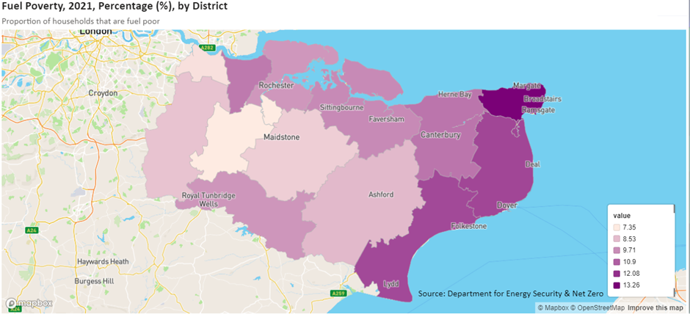
Source: Kent Public Health Observatory

Implications for Strategy
  - There is a lack of local data on non decent homes and properties with Category 1 hazards under the HHSRS. This makes it difficult to assess the scale of poor condition and unsafe properties across Kent and Medway. It is likely that individual authorities have their own systems for identifying these properties, e.g. through stock condition surveys or through the day to day activities of private sector housing teams. However, this is not readily accessible for the purposes of analysis and many authorities do not have up to date stock condition surveys.
  - National rates of non decency and Category 1 hazards applied to Kent and Medway suggest there is a substantial number of poor conditions properties, particularly in the private rented sector. It is estimated that over 18,000 private rented sector properties in Kent and Medway have one or more Category 1 hazards. There are likely to be lower numbers and proportions of poor condition properties in the Social Rented sector because of the impact of the decent homes programme over time.
  - Poor energy efficiency and fuel poverty is concentrated in the coastal authorities but there are problem pockets across Kent and Medway, including in rural areas.
  - The existence of poor conditions has knock on implications for health and wellbeing of households living in Kent and Medway.

Housing, Health & Wellbeing
  - This section examines the interaction between housing, and health and wellbeing outcomes in Kent and Medway.
  - The Marmot Review (2010) identified housing as a ‘social determinant of health’ meaning it can affect physical and mental health inequalities throughout life. The Marmot Review 10 Years On – Health Equity in England, provided additional evidence from the research on the relationship between poor housing and health. The report summarises the relationships as follows:
  - ‘Poor-quality housing harms health and evidence shows that exposure to poor housing conditions (including damp, cold, mould, noise) is strongly associated with poor health, both physical and mental. The longer the exposure to poor conditions, including cold, the greater the impact on mental and physical health. Specific physical effects are morbidity including respiratory conditions, cardiovascular disease and communicable disease transmission, and increased mortality. In terms of mental health impacts, living in non-decent, cold or overcrowded housing and in unaffordable housing has been associated with increased stress and a reduction in a sense of empowerment and control over one’s life and with depression and anxiety. Children living in overcrowded homes are more likely to be stressed, anxious and depressed, have poorer physical health, attain less well at school and have a greater risk of behavioural problems than those in uncrowded homes.’
  - Sir Michael Marmot further summarised the impact on health is driven by three components of housing:
- Cost – the cost and affordability of housing is examined in Section 4.
- Quality – issues of housing conditions and safety are examined in Section 5.
- Security – tenure and insecure housing is considered in Section 4.
  - This provides a useful framework for thinking about housing in Kent and Medway and how it impacts on health outcomes. Whilst it is difficult to identify direct cause and effect relationships between housing attributes and health outcomes at the localised level, the wider national research confirms these relationships. Indeed, the Housing Health and Safety Rating System was developed to reflect health data on people seeking medical assistance due to conditions relating to their housing. Furthermore, in some areas, qualitative evidence and experience of practitioners can identify likely interactions and impacts.
  - This section examines selected headline health indicators in Kent and Medway and considers how housing challenges contribute to outcomes and how improved housing outcomes may lead to better health outcomes. This is essentially the sphere of public health – where prevention activities, including housing interventions, can improve health outcomes. It briefly comments on the need for housing with care relating the growth of the older population.

District Health Profiles
  - The Kent Public Health Observatory provides health profile data for each of the Kent authorities, including Medway for comparison. Overall mortality (death rate) is similar or better than the national average, but there is wide variation between the authority areas. The rate is notably higher in Dover, Folkestone and Hythe, Medway, Swale and Thanet – primarily the coastal areas of the sub-region. In some local authority areas with higher mortality rates, the population of older people (aged 60+) is greater than in other areas, including Dover, Folkestone and Thanet. These authorities also have relatively high proportion of people claiming disability benefits. The mortality rate is lowest in Sevenoaks even though there is also a relatively large older population in this district. Rates of disability claimants are lower however. Medway also has a high mortality rate compared to the Kent districts but a relatively low proportion of older people. The pattern of mortality is therefore complex with ill health not just related to the age of the population but a wider set of factors including deprivation, with housing a component of this.
Table 6-1: Health Profile 2022-23
LA | Mortality rate (deaths per 100,000) | Respiratory mortality | % of people in good or very good health | % disability claimants | % of pop aged 60+
Ashford | 895.9 | 107.1 | 83.0% | 8.9% | 25.7%
Canterbury | 927.6 | 101.9 | 81.7% | 9.5% | 28.3%
Dartford | 993.5 | 82.2 | 85.5% | 7.5% | 18.5%
Dover | 1,008.4 | 117.4 | 79.2% | 11.2% | 31.5%
Folkestone & Hythe | 1,065.1 | 125.6 | 78.2% | 12.4% | 32.5%
Gravesham | 992.2 | 101.1 | 82.8% | 9.1% | 22.9%
Maidstone | 947.0 | 114.9 | 83.8% | 8.0% | 24.8%
Medway | 1,022.5 | 122.9 | 82.1% | 9.4% | 22.3%
Sevenoaks | 799.1 | 82.3 | 84.9% | 7.7% | 28.1%
Swale | 1,031.7 | 115.8 | 80.3% | 11.1% | 25.2%
Thanet | 1,081.0 | 117.7 | 77.0% | 13.1% | 30.5%
Tonbridge and Malling | 910.9 | 73.7 | 84.7% | 7.8% | 25.3%
Tunbridge Wells | 878.1 | 82.5 | 85.3% | 6.8% | 25.8%
Kent + Medway | 968.3 | 105.7 | 82.1% | 9.4% | 25.9%
England & Wales | 976.7 | 108.2 | 82.2% | 8.5% | 24.7%
Source: District Profiles, Kent Public Health Observatory. % aged over 60 is from 2022 ONS mid year estimates, ONS mortality statistics, 2022. People in good heath - Census 2021. Disability claimants - Nov 2023 data from DWP.

Housing and Public Health
  - There are a number of health conditions and health outcomes where there is strong evidence of a link with housing, either in terms of housing costs or affordability, housing insecurity and/or housing conditions. These are considered in this sub section. In the case of most health conditions, causes are multi-factorial, with complex interactions between economic circumstances, living conditions, access to education and health services and deprivation factors. Summaries of some of the housing and health literature is provided in Appendix B.
  - It is worth noting at the outset that Kent and Medway contains some of the most deprived LSOAs within the Country on the Index of Multiple Deprivation’s ‘Living Environment’ Domain. 79 LSOAs within Kent and Medway are in the 10% most deprived in terms of the Living Environment Domain, which includes indoor (quality of housing) and outdoor (air quality and road traffic accidents). 24 of these LSOAs are within Medway, 12 in Maidstone, 7 in Swale, 6 in Dartford and Tunbridge Wells, 5 in Folkestone and Hythe, 5 in Sevenoaks, 3 in Dover and Tonbridge and Malling, 2 in Ashford, 2 in Canterbury, 2 in Thanet, 1 in Gravesham.
  - It is not possible to separate out the housing quality component from the outdoor (air quality and traffic accidents) in this data so this can only give an indication of these living environment factors. However, there are 6 LSOAs which also fall within the top 10% of most deprived areas in terms of the barriers to Housing and Services Domain. Three of these are within Swale, 1 in Folkestone and Hythe, Tonbridge and Malling and Tunbridge Wells.

Respiratory Mortality and Conditions
  - Table 6-2 includes the mortality rate for respiratory conditions in the Kent and Medway authorities (all ages). The average rate for Kent and Medway is 105.7 per 100,000 people.
  - Respiratory disease mortality for those aged under 75 has declined over time in Kent and Medway, from 35.7 per 100,000 in 2014-16 to 29.1 in 2021-23. Deprivation is strongly correlated to the higher rates, varying from a rate of 55.0 in Sheppey to 15.3 in The Ridge.
  - Chronic Obstructive Pulmonary Disease (COPD) is generally declining as a condition across Kent (2.1% to 2.0% 2018/19 to 2022/23) and most sub areas, in large part as a result in reductions in smoking rates. However, it remains above the England average rate of 1.8% and rates vary significantly from 3.9% in The Marsh to 1.1% in Canterbury South.
  - Respiratory admissions in those aged 0-19 were 159 per 100,000 – slightly below England average of 168 but well above 2013/14 figure of 101. Again, the rate varies strongly from 385 in Garden City to 71 in Canterbury South. There appears to be some association with deprivation, but less strong than with respiratory mortality.
  - Poor housing conditions are known to exacerbate respiratory conditions and, in some cases, can cause these conditions to emerge. Domestic mould and ventilation issues are clearly linked to asthma development and exacerbation. The ability to keep homes warm (thermal comfort in the decent homes standard) affects the ability of those with COPD to manage their conditions and avoid exacerbations which may result in hospital admission. The higher rates of fuel poverty examined in Section 5 show that the highest rates in the coastal areas also match the highest rates of COPD prevalence, indicating the risk that households with this condition may be less able to manage their conditions due to living in cold homes, or being unable to afford adequate heating.
  - Asthma prevalence across Kent is 6.2% of the population – below the England average of 6.5% but has increased from 6.0% in 2021/21. Prevalence varies significantly, from 7.6% in Herne Bay to 4.7% in Gravesend Central. The varying rates may be influenced by testing regimes in different primary care networks, personal health variation (e.g. smoking) and environmental factors (e.g. pollution), but there is also a link with housing quality.
  - The presence of mould in the homes, more likely in damp homes, and lower quality living environments are also linked to pneumonia acquisition and severity. Influenza and pneumonia admissions in people aged 65+ in Kent and Medway were 1,257 per 100,000 – below the England average of 1,651 and lower than 1,340 in 2013/14 but trends appear strongly impacted by Covid years. The current rate varies from 2,268 in Gravesend Alliance PCN to 705 in Canterbury North. However, there is also a link between prevalence and vaccine uptake, underlining the complexity of establishing cause and effect in these areas.
Map 6-1: COPD Prevalence 2022/23
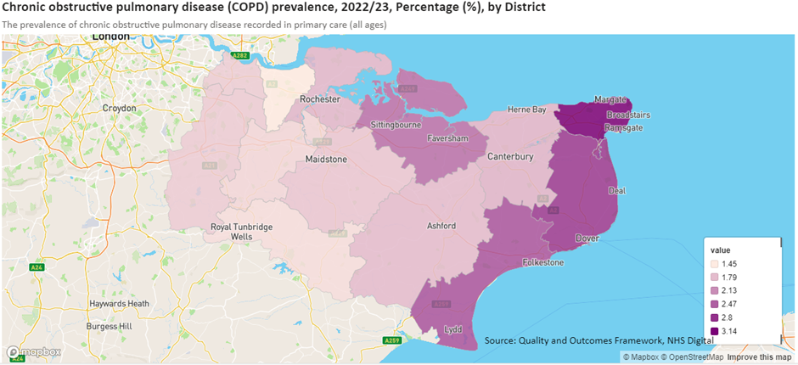
Source: Kent Public Health Observatory
Map 6-2: Influence and Pneumonia Admissions Aged 65+

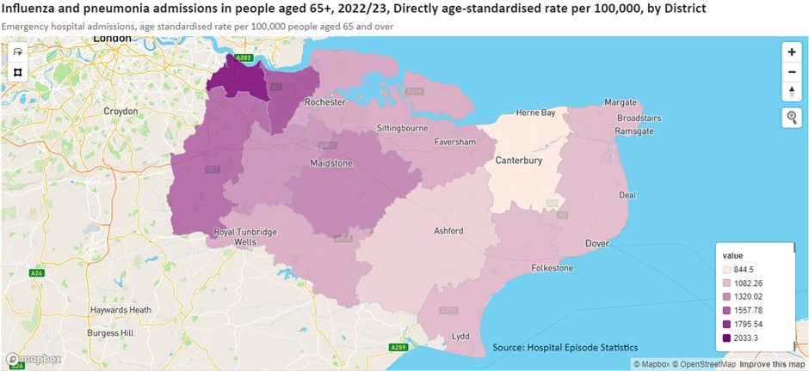
Source: Kent Public Health Observatory

Cold Homes and Falls amongst Older People
  - There is an established causal link between cold homes leading to falls among older people (particularly those with circulatory and ambulatory conditions), leading to higher hospital admissions, excess winter deaths and fractures to hips and legs as well as less serious injuries, though the latter can have longer term impacts on mobility and social isolation.
  - Section 5 presented the pattern of fuel poverty across Kent and Medway which is likely to be a good indicator of the concentration of cold homes across the sub-region.
  - Falls admissions in those aged 65+ resulting in hip and leg fractures were 550 per 100,000 for Kent in 2020/21-2022/23, down from 587 in 2014/15-2016-17. This is above the England average of 534 but varies from 865 in Medway Central to 438 in Dartford Central.
  - There is a higher rate of hip and leg fractures in older people in the coastal areas of Kent – in Thanet and Dover. This may be linked to the existence of more cold homes in these districts and higher rates of fuel poverty, resulting in older people living in temperatures that affect their movement and in which they are more likely to experience falls. There are also high numbers of older properties with stepped entrances (such as Victorian homes) in the seaside towns in these districts which may also impact on accessibility and contribute to a higher incidence of falls.
  - There is also a high rate in Sevenoaks however, where fuel poverty rates are low. This does not mean that older people in Sevenoaks, particularly those living in larger rural properties, are able keep their homes warm however and the nature of the housing stock may play a part in this pattern too. The pattern is not clear cut however, but it is likely that cold homes play a contributory factor in some locations.
Map 6-3: Falls Admissions in People Aged 65+

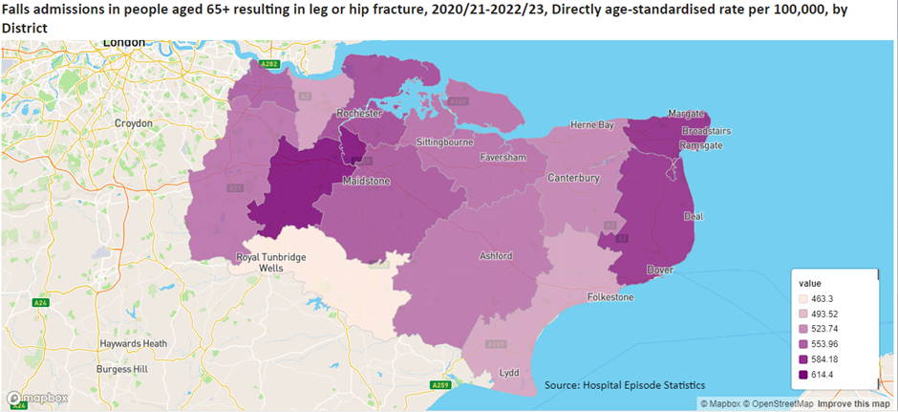
Source: Kent Public Health Observatory

Mental Health Impacts and Childhood Development
  - The importance of affordable and good quality housing in supporting mental as well as physical health is established amongst housing practitioners and supported by a range of literature. The Marmot Review – 10 Years On is worth quoting again in this respect:
  - ‘In terms of mental health impacts, living in non-decent, cold or overcrowded housing and in unaffordable housing has been associated with increased stress and a reduction in a sense of empowerment and control over one’s life and with depression and anxiety. Children living in overcrowded homes are more likely to be stressed, anxious and depressed, have poorer physical health, attain less well at school and have a greater risk of behavioural problems than those in uncrowded homes.’
  - Map 6-4 presents the rate of overcrowding in households across Kent and Medway. Across all tenures, the rates are highest in Dartford and Gravesham (over 7% of households are overcrowded). Note that this mapped data is based on rooms rather than bedrooms. This may be linked to poor affordability in these areas, in part due to the proximity of London. There is a general pattern of worse overcrowding along the northern coastal areas of Swale, Canterbury and Thanet but also in Tunbridge Wells. It is useful to break this down by tenure.
  - Over 26,000 households in Kent and Medway live in overcrowded homes (they have 1 or more too few bedrooms for their household size). The largest number of these households live in the private rented sector (9,378), followed by the social rented sector (9,072). In Kent and Medway as a whole however, 10% of households living in social rented housing are over crowded, with 7% of those living in the PRS and 2% in the owner occupied sector.
Table 6-2: Households Living in Overcrowded Homes, 2021
Area | Total | Owned | Social rented | Private rented
Ashford | 1,821 | 602 | 693 | 526
Dartford | 2,581 | 778 | 874 | 929
Dover | 1,593 | 444 | 596 | 553
Folkestone and Hythe | 1,518 | 451 | 416 | 651
Gravesham | 2,512 | 713 | 818 | 981
Maidstone | 2,426 | 770 | 770 | 886
Medway | 5,050 | 1,647 | 1,483 | 1,920
Sevenoaks | 1,238 | 381 | 556 | 301
Swale | 2,417 | 767 | 933 | 717
Thanet | 2,308 | 502 | 703 | 1,103
Tonbridge and Malling | 1,344 | 397 | 671 | 276
Tunbridge Wells | 1,382 | 288 | 559 | 535
Kent and Medway | 26,190 | 7,740 | 9,072 | 9,378
South East | 131,349 | 36,976 | 46,338 | 48,035
England | 1,024,691 | 275,296 | 386,033 | 363,362
Source: Census 2021
  - The rate of overcrowding in the social rented sector is at or above 10% in Dartford, Gravesham, Medway, Swale and Thanet. Dartford and Gravesham also have higher rates of overcrowding in the PRS and owner occupied sectors compared to the other authorities and the region and England as a whole. The pattern of overcrowding reflects poor affordability of housing for those on low incomes and the lack of availability of Affordable Housing, including larger homes, for overcrowded households already living in the sector to move in to.

Table 6-3: Households Living in Overcrowded Homes %, 2021
Area | Owned | Social rented | Private rented
Ashford | 2% | 9% | 5%
Dartford | 3% | 14% | 11%
Dover | 1% | 8% | 6%
Folkestone and Hythe | 1% | 8% | 6%
Gravesham | 3% | 11% | 12%
Maidstone | 2% | 8% | 7%
Medway | 2% | 10% | 9%
Sevenoaks | 1% | 9% | 5%
Swale | 2% | 12% | 6%
Thanet | 1% | 10% | 7%
Tonbridge and Malling | 1% | 8% | 4%
Tunbridge Wells | 1% | 8% | 6%
Kent and Medway | 2% | 10% | 7%
South East | 1% | 9% | 7%
England | 2% | 10% | 8%
Source: Census 2021
Map 6-4: Overcrowding, 2021

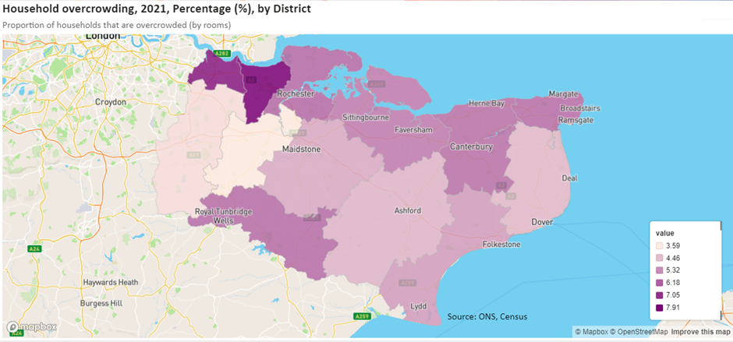
Source: Kent Public Health Observatory
Map 6-5: Prevalence of Serious Mental Illness, Kent and Medway, 2022/23

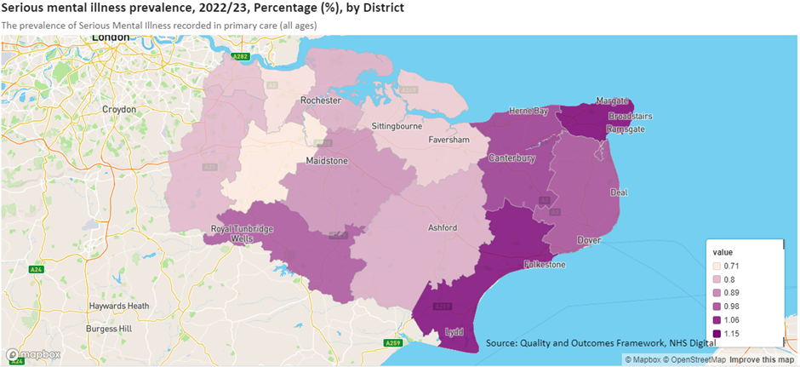
Source: Kent Public Health Observatory
  - The highest rates of serious mental illness are found in Thanet and Folkestone and Hythe with relatively high rates in Canterbury, Dover and Tunbridge Wells. The incidence of serious mental illness is up slightly in most areas across Kent and Medway from 0.8% to 0.9% across Kent between 2018/19 and 2022/23. This is below the England average of 1.0% but varies at more localised scales from 1.3% in Margate to 0.6% in Strood. There is a clear contrast between the most (1.2%) and least deprived (0.8%) decile in terms of the rate of serious mental illness.
  - Whilst serious mental illness may not be caused by housing factors, the cost of housing, overcrowding, living in insecure and poor conditions can contribute to mental illness or exacerbate existing conditions.
  - As examined in Section 5, there are 3,597 children who are homeless and living in temporary accommodation in Kent and Medway (as at March 2024). This is one of the most insecure forms of housing, often lacking in adequate space and facilities and families can sometimes be placed a long distance from schools, impacting on attendance, behaviour, and longer term educational outcomes according to a survey of teachers, undertaken for research by Shelter in 2020. Teachers in this research also reported on the impact of housing costs on these children leading to lack of funds for food, including breakfast, with impacts on ability to concentrate in class.
  - It is highly likely that a proportion of children currently living in temporary accommodation in Kent and Medway will experience negative impacts on their health and wellbeing as a result of their housing situation. A Shelter study in 2006 found that poor housing conditions increase the risk of severe ill health or disability by up to 25% during childhood and early adulthood.

Housing and Care
  - A key area in the consideration of the impact of housing on health is the changing demographic make up of Kent and Medway, with the ageing of the population the main driver of change. The growth in the number of older people, particularly those in the older age groups, is associated with increased health and mobility problems and demand for support and care within housing.
  - Almost 20% of the Kent and Medway population is aged 65 and over, with 9% aged over 75 and 2.5% aged over 85. The demand for specialist older persons housing is typically estimated by reference to the size of the population aged 75 and over. The majority of those aged 85 and over will have some form of care or support need.
Table 6-4: Number of Older People in the Population 2021
 | 65+ | 75+ | 85 + | Total (All ages)
Ashford | 25,997 | 12,105 | 3,199 | 132,747
Canterbury | 34,250 | 16,334 | 4,696 | 157,430
Dartford | 16,038 | 7,436 | 2,214 | 116,753
Dover | 27,899 | 12,844 | 3,439 | 116,409
Folkestone and Hythe | 27,428 | 12,737 | 3,474 | 109,758
Gravesham | 18,414 | 8,705 | 2,490 | 106,900
Maidstone | 33,525 | 15,691 | 4,400 | 175,782
Sevenoaks | 25,928 | 12,587 | 3,827 | 120,512
Swale | 28,912 | 12,936 | 3,262 | 151,677
Thanet | 33,258 | 15,503 | 4,267 | 140,588
Tonbridge and Malling | 25,306 | 12,134 | 3,362 | 132,201
Tunbridge Wells | 22,373 | 11,043 | 3,397 | 115,311
Medway | 46,057 | 20,122 | 5,163 | 279,776
Kent and Medway | 365,384 | 170,177 | 47,188 | 1,855,842
South East | 1,804,258 | 860,437 | 253,377 | 9,278,066
England | 10,401,303 | 4,837,160 | 1,372,301 | 56,490,048
Source: Census 2021
  - There are higher proportions of older people, including in the oldest age category (85+) in Dover, Folkestone and Hythe and Thanet. Sevenoaks and Canterbury also have high proportions of their population in the older age groups (75+ and 85+) compared to Kent and Medway as a whole as well as the South East and England (Table 6-5). The rate of growth in the older cohorts of the population over the last 10 years has been substantial, particularly in the 70-74 and 75-79 age groups as the ‘baby boom’ cohort ages (Table 6-6).
Table 6-5: Proportion of Older People in the Population 2021
 | 65+ | 75+ | 85+
Ashford | 19.6% | 9% | 2.4%
Canterbury | 21.8% | 10% | 3.0%
Dartford | 13.7% | 6% | 1.9%
Dover | 24.0% | 11% | 3.0%
Folkestone and Hythe | 25.0% | 12% | 3.2%
Gravesham | 17.2% | 8% | 2.3%
Maidstone | 19.1% | 9% | 2.5%
Sevenoaks | 21.5% | 10% | 3.2%
Swale | 19.1% | 9% | 2.2%
Thanet | 23.7% | 11% | 3.0%
Tonbridge and Malling | 19.1% | 9% | 2.5%
Tunbridge Wells | 19.4% | 10% | 2.9%
Medway | 16.5% | 7% | 1.8%
Kent and Medway | 19.7% | 9% | 2.5%
South East | 19.4% | 9% | 2.7%
England | 18.4% | 9% | 2.4%
Source: Census 2021
Table 6-6: Growth in Older Age Groups 2011-2021
 | 65 to 69 | 70 to 74 | 75 to 79 | 80 to 84 | 85 +
Ashford | 7.4% | 56.9% | 46.1% | 28.4% | 17.1%
Canterbury | 7.3% | 46.8% | 32.9% | 9.0% | 2.9%
Dartford | 11.8% | 32.5% | 4.5% | 5.5% | 18.0%
Dover | 9.8% | 47.7% | 36.7% | 14.7% | 7.7%
Folkestone and Hythe | 7.8% | 50.2% | 34.9% | 12.5% | 1.9%
Gravesham | 4.3% | 25.5% | 7.1% | 10.7% | 21.6%
Maidstone | 6.7% | 48.3% | 33.4% | 23.8% | 25.2%
Sevenoaks | 1.5% | 39.6% | 22.9% | 10.9% | 30.3%
Swale | 6.5% | 51.2% | 40.0% | 23.6% | 22.7%
Thanet | 7.2% | 45.0% | 29.1% | 3.2% | -5.9%
Tonbridge and Malling | 4.2% | 37.8% | 27.2% | 24.9% | 38.0%
Tunbridge Wells | -0.7% | 41.5% | 26.6% | 7.2% | 15.6%
Medway | 11.5% | 43.6% | 27.7% | 21.7% | 17.2%
Kent and Medway | 6.9% | 44.4% | 29.3% | 15.1% | 14.4%
South East | 9.0% | 41.9% | 26.7% | 14.0% | 16.7%
England | 10.3% | 36.8% | 22.1% | 13.3% | 16.3%
Source: Census 2021 and 2011
  - There is a strong correlation between ageing and increased rates of disability and ill health. The need for support and care associated with health problems can also trigger the need for specialist housing (or care in own home) to remain independent.
  - In Kent and Medway as a whole, 14.4% of people aged 65+ have disabilities that limit their day to day lives a lot. A further 18% have disabilities that limit their day to day lives a little. A further 9.5% have a long term health problem but it is not described as a disability. Around one third of older people (aged 65 plus) have disabilities that affect their lives.

Table 6-7: Older People (Aged 65+) with Disabilities
 | Disabled, day-to-day activities limited a lot |  | Disabled, day-to-day activities limited a little |  | Not disabled, but has a long-term health condition |  | No disability or long-term health condition |  | Total 65+ pop.
 | No. | % | No. | % | No. | % | No. | %
Ashford | 3,381 | 13.3% | 4,532 | 17.8% | 2,329 | 9.2% | 15,165 | 59.7% | 25,407
Canterbury | 4,664 | 14.1% | 6,122 | 18.5% | 3,296 | 9.9% | 19,081 | 57.5% | 33,163
Dartford | 2,276 | 14.6% | 2,800 | 18.0% | 1,320 | 8.5% | 9,172 | 58.9% | 15,568
Dover | 4,151 | 15.3% | 5,085 | 18.8% | 2,556 | 9.4% | 15,276 | 56.4% | 27,068
Folkestone and Hythe | 4,057 | 15.3% | 4,959 | 18.7% | 2,566 | 9.7% | 14,987 | 56.4% | 26,569
Gravesham | 2,825 | 15.6% | 3,203 | 17.7% | 1,516 | 8.4% | 10,545 | 58.3% | 18,089
Maidstone | 4,271 | 13.1% | 5,741 | 17.6% | 3,181 | 9.8% | 19,423 | 59.6% | 32,616
Sevenoaks | 2,995 | 11.8% | 4,274 | 16.9% | 2,658 | 10.5% | 15,372 | 60.8% | 25,299
Swale | 4,445 | 15.7% | 5,145 | 18.2% | 2,448 | 8.7% | 16,221 | 57.4% | 28,259
Thanet | 5,459 | 16.9% | 6,225 | 19.3% | 2,935 | 9.1% | 17,608 | 54.6% | 32,227
Tonbridge and Malling | 3,134 | 12.6% | 4,203 | 16.9% | 2,567 | 10.3% | 14,979 | 60.2% | 24,883
Tunbridge Wells | 2,472 | 11.4% | 3,632 | 16.8% | 2,379 | 11.0% | 13,133 | 60.8% | 21,616
Medway | 6,973 | 15.5% | 8,143 | 18.1% | 4,124 | 9.2% | 25,769 | 57.3% | 45,009
Kent and Medway | 51,098 | 14.4% | 64,059 | 18.0% | 33,875 | 9.5% | 206,734 | 58.1% | 355,766
South East | 225,221 | 12.9% | 307,740 | 17.6% | 175,592 | 10.0% | 1,043,642 | 59.6% | 1,752,195
England | 1,572,334 | 15.5% | 1,842,499 | 18.2% | 914,056 | 9.0% | 5,787,259 | 57.2% | 10,116,148
Source: Census 2021
  - Our review of LHNAs across Kent and Medway considered the estimated need for older persons housing (excluding care homes) which is included in each of the studies at the local authority area (Appendix A). Collectively, the studies identify need for 13,400 homes for older people, providing various levels of care and support. The studies consider different time periods consistent with their own plan periods. However, this gives an indication of the scale of need to accommodate the growing older population.
  - It is important to note that the majority of older people in Kent and Medway will continue to live in mainstream housing all of their lives. However, the growing size of the older population will increase need for specialist housing, even if market share of specialist housing remains consistent.
  - Care and support is generally provided within the home, with unpaid carers providing a significant contribution particularly in rural areas where it may be more challenging to procure care/support in the home.
  - Specialist housing with care (extra care or assisted living) is limited within Kent and Medway and there are challenges with providing more schemes due to the difficulty in competing for sites with mainstream house builders and other barriers.
  - Increased accessibility and adaptability standards in new homes can provide older people and people with disabilities with more suitable accommodation as they age and when they need care or support. Policies on the proportion of M4(2) (broadly equivalent to former Lifetime Homes Standards) and M4(3) (wheelchair accessible) homes to be delivered are now emerging in Local Plans but there is a lack of data on what is actually being delivered. Government has also indicated its intention to make M4(2) mandatory within building regulations which would negate the need for specific Local Plan policies, however this has not yet been confirmed.

Implications for Strategy
  - Poor housing conditions in some properties as well as overcrowding and acute housing needs affecting a substantial proportion of the population are resulting in detrimental impacts on health and wellbeing in Kent and Medway. There appear to be links between poor condition properties, fuel poverty and respiratory conditions as well as falls amongst older people.
  - Overcrowding and living in insecure housing such as temporary accommodation is known to have impacts on childhood wellbeing and development.
  - An ageing population in Kent and Medway, common to England as a whole, means that more people will affected by health problems and will need suitable accommodation for care and support if and when they need it. The expansion of specialist accommodation is required across Kent and Medway according to evidence in the local authority level LHNAs. Mainstream housing also needs to be suitable, in terms of accessibility, to house the growing older population.
  - Whilst limited by data availability, this section has demonstrated key areas of overlap between housing and health within Kent and Medway, highlighting the importance of providing sufficient housing of high quality to support better health and wellbeing outcomes.

Delivery
  - This section examines the delivery record for new homes across Kent and Medway, drawing on completions data sourced from Government housing statistics.
  - Between 2011-12 and 2022-23, a total of 75,301 net additional dwellings were delivered across Kent and Medway. 36,384 of these additional homes were delivered in the past 5 years (2018-19 to 2022-23) equating to 7,277 per annum. Adopted Local Plans across Kent and Medway collectively have requirements for the provision of 9,160 dwellings per annum. Delivery in the last 5 years has been below the required level therefore.
  - As shown in the summary table below, the scale of delivery has been highest in Maidstone, Swale, Medway, Ashford and Dartford, and lowest in Gravesham, Sevenoaks and Tunbridge Wells. Annual and cumulative completions are also displayed in graph form below.
Table 7-1: Net additional dwelling completions, local authority
 | 2011-12 to 2022-23 (11 years) | 2018-19 to 2022-23  (5 years)
Ashford | 8,534 | 4,449
Canterbury | 5,423 | 2,383
Dartford | 7,979 | 3,277
Dover | 4,435 | 2,323
Folkestone and Hythe | 4,448 | 2,272
Gravesham | 3,212 | 1,565
Maidstone | 12,723 | 6,777
Sevenoaks | 3,757 | 1,565
Swale | 10,018 | 4,720
Thanet | 5,131 | 2,541
Tonbridge and Malling | 6,474 | 2,110
Tunbridge Wells | 3,167 | 2,401
Medway | 9,397 | 4,946
Kent and Medway | 75,301 | 36,384
Kent and Medway per annum | 6,845 | 7,277
Source: Net additional dwellings by local authority district, England 2001-02 to 2022-23, Table 122
Figure 7-1: Net annual dwelling completions, local authority, 2011-12 to 2022-23

Source: Net additional dwellings by local authority district, England 2001-02 to 2022-23, Table 122

  - In terms of the tenure mix of new housing, Affordable Housing made up 23.1% of all net completions across Kent and Medway between 2011-12 and 2022-23. The proportion is slightly higher, at 23.6% for the last 5 years only. This equates to 1,522 net additions of Affordable Homes per annum over the last 5 years. As discussed in Section 5, estimated need for Affordable Housing in Kent and Medway is around four times higher.
  - Note that this data has been updated to 2023-24, but is presented to 2022-23 to align with the data on overall net completions (considered above) and the components of supply (considered below). In 2023-24 there were a further 4,370 market and 1,630 affordable completions across Kent and Medway as a whole.
Table 7-2: Split between Market and Affordable Completions 2011-2023
 | 2011-12 to 2022-23 |  |  | 2018-19 to 2022-23
 | Market | Affordable | % Aff. | Market | Affordable | % Aff.
Ashford | 4,870 | 1,150 | 19.1% | 2,370 | 560 | 19.1%
Canterbury | 3,600 | 590 | 14.1% | 1,550 | 420 | 21.3%
Dartford | 6,450 | 1,430 | 18.1% | 2,730 | 840 | 23.5%
Dover | 3,330 | 550 | 14.2% | 1,920 | 200 | 9.4%
Folkestone and Hythe | 2,010 | 230 | 10.3% | 1,090 | 150 | 12.1%
Gravesham | 1,450 | 690 | 32.2% | 900 | 460 | 33.8%
Maidstone | 5,820 | 5,380 | 48.0% | 3,230 | 2,810 | 46.5%
Sevenoaks | 1,380 | 200 | 12.7% | 680 | 100 | 12.8%
Swale | 3,640 | 740 | 16.9% | 1,810 | 340 | 15.8%
Thanet | 1,740 | 510 | 22.7% | 860 | 280 | 24.6%
Tonbridge and Malling | 4,310 | 860 | 16.6% | 1,370 | 300 | 18.0%
Tunbridge Wells | 2,430 | 370 | 13.2% | 1,620 | 220 | 12.0%
Medway | 5,560 | 1,310 | 19.1% | 3,200 | 540 | 14.4%
Kent + Medway | 46,590 | 14,010 | 23.1% | 23,330 | 7,220 | 23.6%
Source: MHCLG House building: permanent dwellings started and completed, by tenure and district, Table 253
Figure 7-2: Market and affordable completions, local authority, 2011-12 to 2022-23

Source: MHCLG
  - Rates of affordable housing delivery vary significantly between the authorities, from 10.3% in Folkestone and Hythe to 48.0% in Maidstone (over the entire period). New Affordable Housing delivery in Maidstone has accounted for around one third of all new delivery across Kent and Medway in the last 5 years.
  - Government statistics also break down net additional dwellings by the components of housing supply, which include new build development, conversion, change of use, and other sources (a catch-all category in the statistics).
  - Across Kent and Medway, new build represents by far the largest source of housing delivery, at 86.4% of all completions between 2012-13 and 2022-23 (this data is not available for 2011-12 or earlier).
  - How this has varied over time across Kent and Medway is displayed in Figure 7-3 below. The larger proportion of non-new build additions in 2016-17 and 2017-18 is due to the introduction of Permitted Development Rights for office to residential conversion in 2015-16: PDR significantly increases the volume of delivery through change of use in those years, representing 34% and 45% of that component of supply in 2016-17 and 2017-18 respectively. This reflects a ‘rush’ to deliver PDR schemes (primarily office to residential) in its first years, following a lead-in time (which explains the limited volume in 2015-16), before tailing off moderately in future years as the availability of suitable conversion opportunities dwindles.
  - Figure 7-4 magnifies the non- new build components of supply to show the proportion they make up of all delivery, for each local authority. PDR varies significantly as a share of all change of use development between the authorities, from 5% in Thanet to 41% in Maidstone.
Figure 7-3: Components of supply by year, Kent and Medway, 2012-13 to 2022-23

Figure 7-4: Proportion of supply (non- new build), local authority, 2012-13 to 2022-23

Source: Component flows of housing supply, net additional dwellings, by local authority, Table 123

Implications for Strategy
  - Accelerating the delivery of new homes is a current theme in the Kent and Medway Housing Strategy and the evidence in this report demonstrates that it remains critical to achieving a range of housing objectives.
  - The delivery of new homes has averaged 7,277 per annum over the last 5 years in Kent and Medway. This rate of delivery is higher than that achieved in the previous 5 years. However, it remains substantially below current adopted Local Plan housing requirements which collectively equate to 9,160 dwellings per annum across Kent and Medway.
  - New build completions are the main source of new homes within Kent and Medway but permitted development (e.g. conversion of offices to homes) has provided some additional supply, particularly post 2016.
  - Affordable housing completions have accounted for 23.6% of new completions over the last 5 years. However, most local authority areas are delivering less than 20% Affordable Housing with the Kent and Medway average affected by strong delivery in recent years in Maidstone.
- Tables and Charts
Map A-1
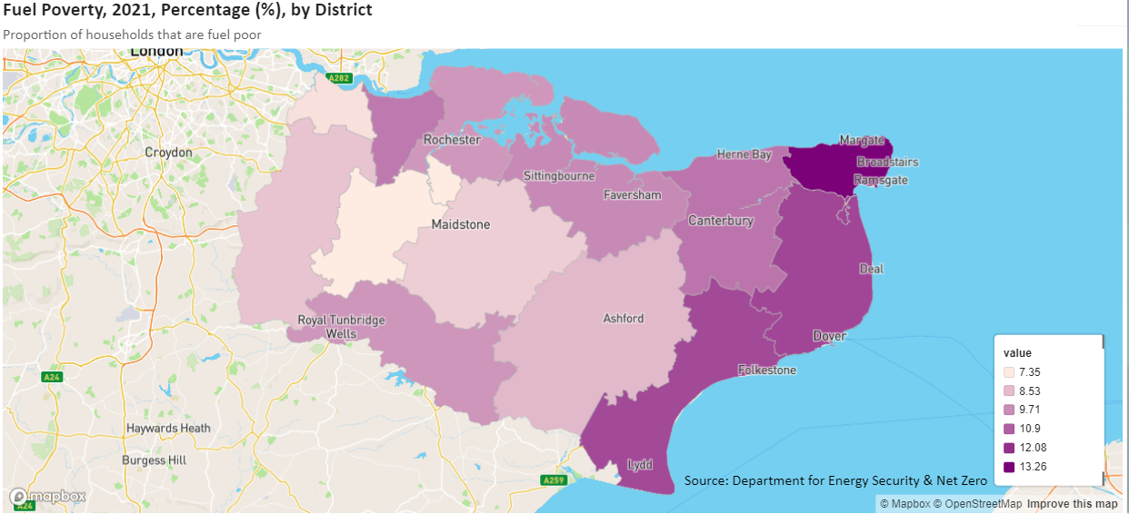
Map A-2:
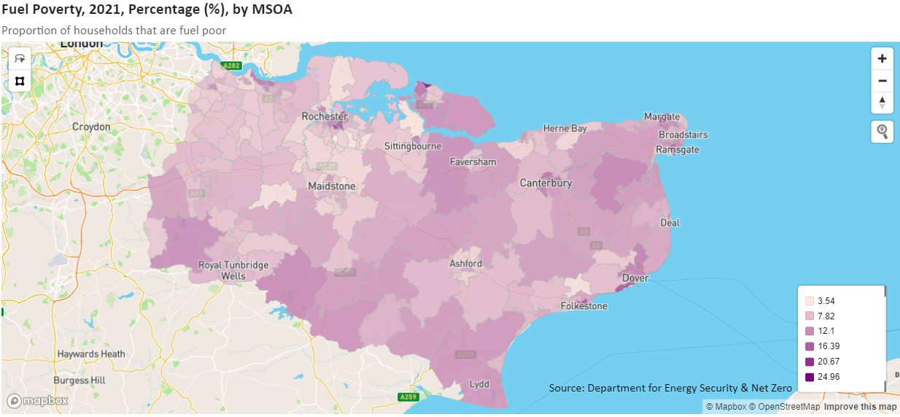

Map A-3:
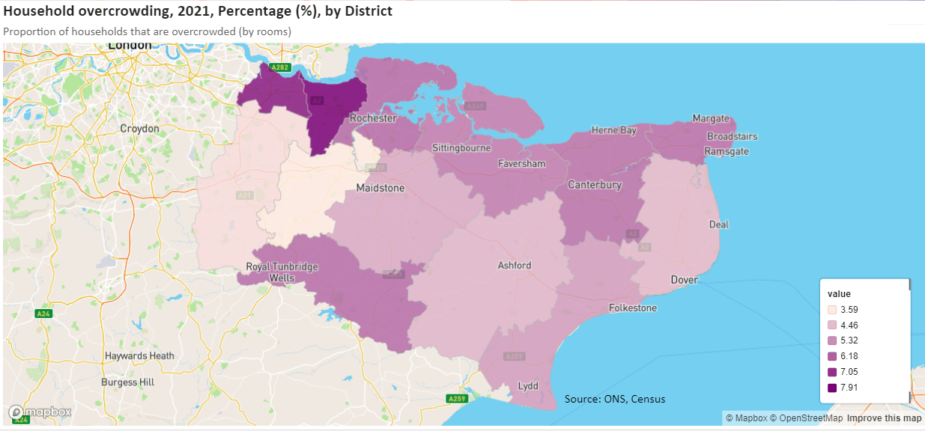
Map A-4:
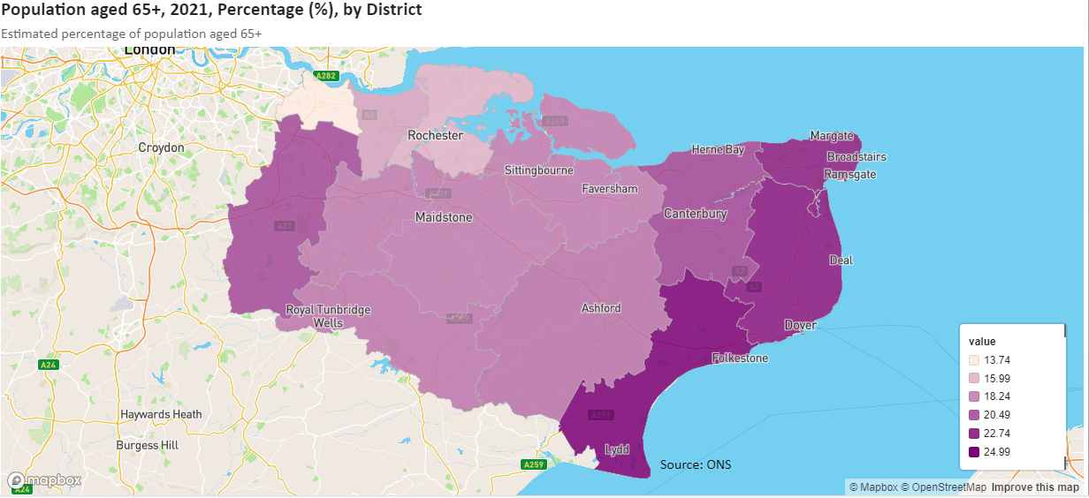
Map A-5:
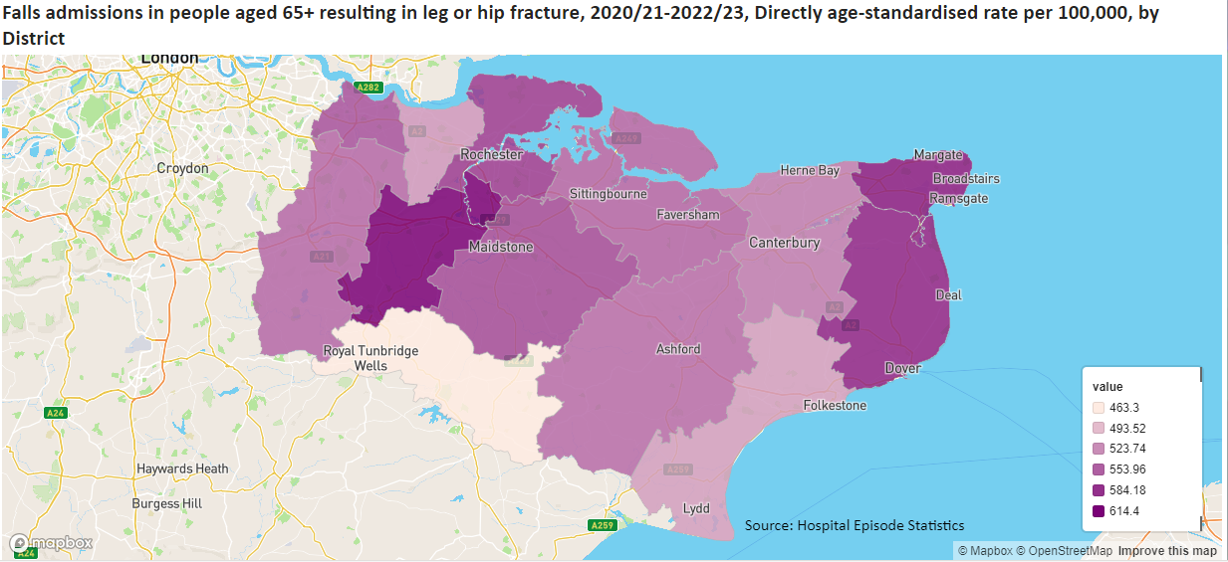
Map A-6:
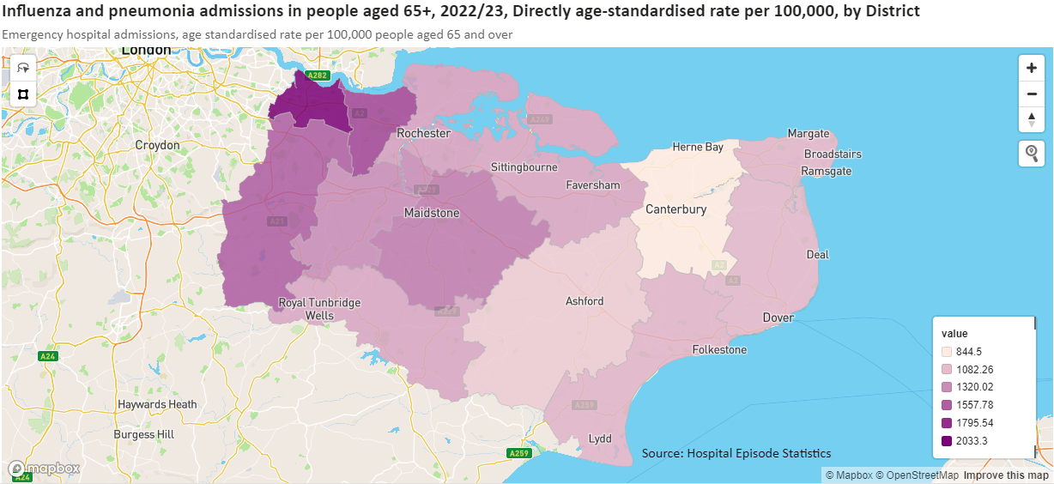
Map A-7:
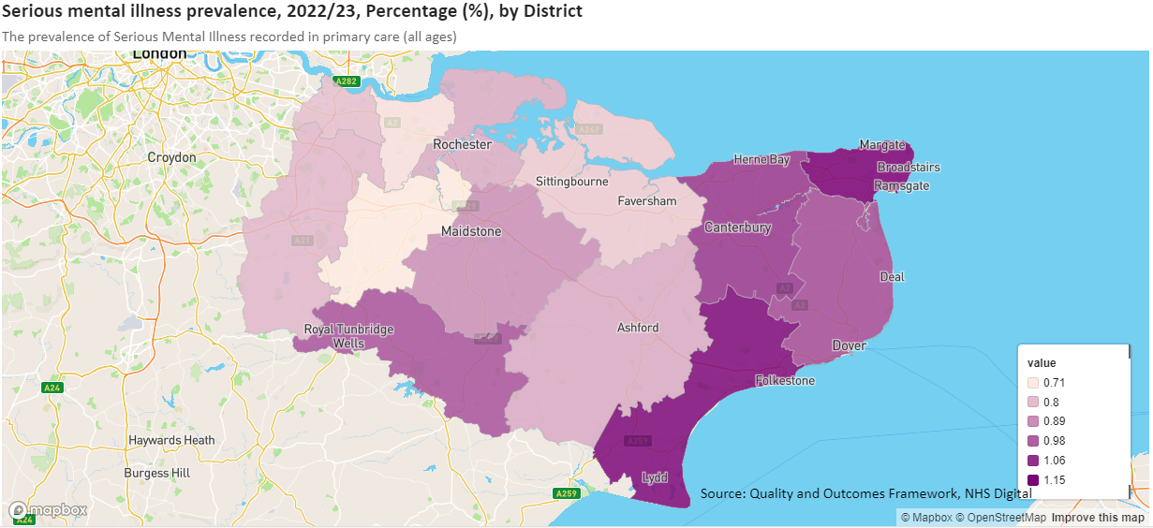
Map A-8:
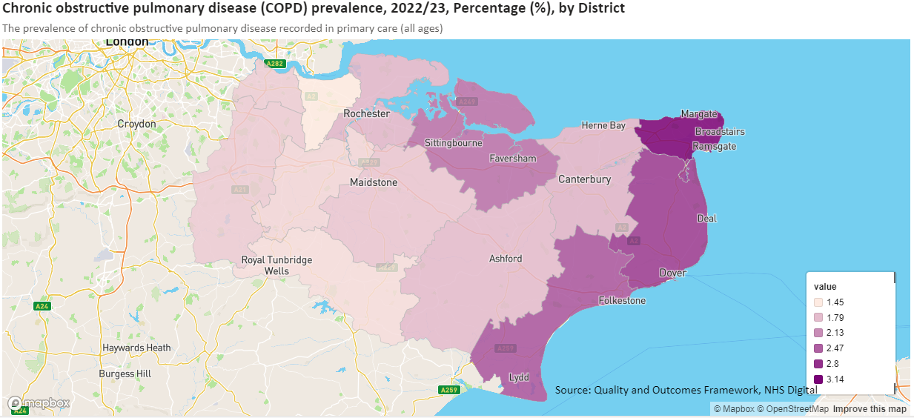
Map A-9:
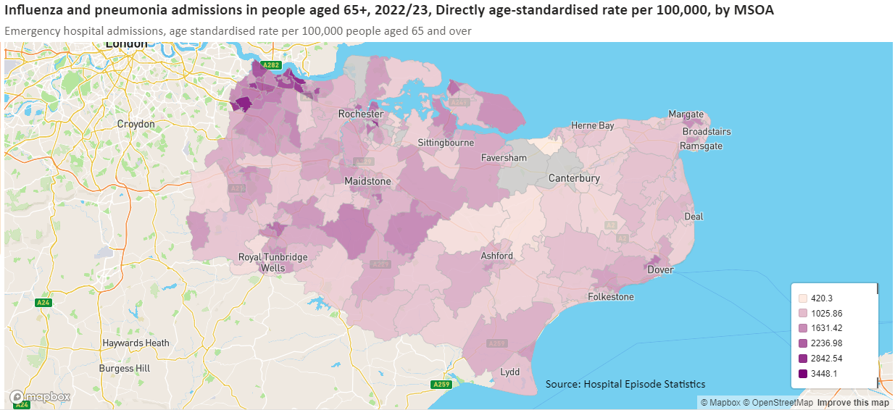

 | 0 to 4 | 5 to 9 | 10 to 14 | 15 to 19 | 20 to 24 | 25 to 29 | 30 to 34 | 35 to 39 | 40 to 44 | 45 to 49 | 50 to 54 | 55 to 59 | 60 to 64 | 65 to 59 | 70 to 74 | 75 to 79 | 80 to 84 | 85 +
Ashford | 5.7% | 6.3% | 6.4% | 5.5% | 4.9% | 6.0% | 6.7% | 6.3% | 6.2% | 6.4% | 7.5% | 7.0% | 5.6% | 5.0% | 5.5% | 4.1% | 2.6% | 2.4%
Canterbury | 4.3% | 4.9% | 5.3% | 8.0% | 10.0% | 5.5% | 5.3% | 5.3% | 5.2% | 5.7% | 6.3% | 6.5% | 5.8% | 5.4% | 6.0% | 4.4% | 3.0% | 3.0%
Dartford | 7.1% | 7.1% | 6.9% | 5.3% | 4.8% | 6.8% | 8.4% | 8.2% | 7.5% | 6.7% | 6.6% | 6.0% | 4.8% | 3.7% | 3.6% | 2.5% | 1.9% | 1.9%
Dover | 4.9% | 5.6% | 5.8% | 5.1% | 4.6% | 5.6% | 5.9% | 5.7% | 5.4% | 5.8% | 7.0% | 7.6% | 7.0% | 6.3% | 6.6% | 4.9% | 3.2% | 3.0%
Folkestone and Hythe | 4.7% | 5.3% | 5.6% | 4.8% | 4.8% | 5.3% | 5.6% | 5.4% | 5.7% | 6.1% | 7.3% | 7.6% | 6.9% | 6.3% | 7.1% | 5.1% | 3.4% | 3.2%
Gravesham | 6.2% | 6.7% | 6.7% | 5.8% | 5.3% | 6.1% | 7.1% | 7.0% | 6.5% | 6.4% | 7.0% | 6.7% | 5.4% | 4.5% | 4.6% | 3.4% | 2.5% | 2.3%
Maidstone | 5.9% | 6.2% | 5.9% | 5.1% | 5.0% | 6.4% | 7.0% | 6.8% | 6.4% | 6.6% | 7.2% | 6.8% | 5.6% | 4.9% | 5.3% | 3.8% | 2.6% | 2.5%
Sevenoaks | 5.6% | 6.3% | 6.7% | 5.4% | 4.1% | 4.7% | 5.5% | 6.1% | 6.5% | 6.8% | 7.3% | 7.3% | 6.1% | 5.3% | 5.8% | 4.3% | 3.0% | 3.2%
Swale | 5.9% | 6.2% | 6.3% | 5.4% | 5.2% | 6.2% | 6.9% | 6.6% | 6.1% | 6.2% | 7.0% | 7.1% | 5.9% | 5.0% | 5.5% | 3.8% | 2.5% | 2.2%
Thanet | 5.2% | 5.7% | 5.9% | 5.1% | 4.8% | 5.5% | 6.1% | 5.9% | 5.7% | 6.0% | 6.9% | 7.1% | 6.4% | 6.0% | 6.6% | 4.8% | 3.2% | 3.0%
Tonbridge and Malling | 5.8% | 6.5% | 6.6% | 5.7% | 4.4% | 5.4% | 6.1% | 6.3% | 6.6% | 7.1% | 7.5% | 7.1% | 5.8% | 4.8% | 5.2% | 3.9% | 2.8% | 2.5%
Tunbridge Wells | 5.3% | 6.2% | 7.1% | 5.6% | 4.2% | 5.2% | 5.9% | 6.3% | 6.8% | 7.4% | 7.8% | 7.0% | 5.9% | 4.7% | 5.1% | 3.9% | 2.7% | 2.9%
Medway | 6.2% | 6.6% | 6.4% | 5.8% | 5.7% | 6.6% | 7.3% | 7.0% | 6.6% | 6.3% | 6.8% | 6.7% | 5.6% | 4.6% | 4.6% | 3.2% | 2.2% | 1.8%
Kent + Medway | 5.6% | 6.1% | 6.3% | 5.6% | 5.4% | 5.9% | 6.5% | 6.4% | 6.3% | 6.4% | 7.1% | 6.9% | 5.9% | 5.1% | 5.4% | 3.9% | 2.7% | 2.5%
South East | 5.3% | 6.0% | 6.1% | 5.6% | 5.6% | 5.9% | 6.5% | 6.6% | 6.5% | 6.6% | 7.1% | 6.9% | 5.8% | 5.0% | 5.2% | 3.9% | 2.7% | 2.7%
England | 5.4% | 5.9% | 6.0% | 5.7% | 6.0% | 6.6% | 7.0% | 6.7% | 6.3% | 6.4% | 6.9% | 6.7% | 5.8% | 4.9% | 5.0% | 3.6% | 2.5% | 2.4%
Table A-1: Age Profile of the Kent and Medway Population in 5 Year Age Bands, 2021
Source: Census 2021

Table A-2: Change in Population by Age Band, 2011-2021
 | 0 to 4 | 5 to 9 | 10 to 14 | 15 to 19 | 20 to 24 | 25 to 29 | 30 to 34 | 35 to 39 | 40 to 44 | 45 to 49 | 50 to 54 | 55 to 59 | 60 to 64 | 65 to 59 | 70 to 74 | 75 to 79 | 80 to 84 | 85 +
Ashford | -2.1% | 13.0% | 9.2% | -4.1% | 3.6% | 23.0% | 35.2% | 10.3% | -13.9% | -7.7% | 33.2% | 37.7% | -3.0% | 7.4% | 56.9% | 46.1% | 28.4% | 17.1%
Canterbury | -9.2% | 3.2% | -0.4% | -5.3% | -2.7% | 0.1% | 15.9% | 5.8% | -13.4% | -7.2% | 13.2% | 21.8% | -5.5% | 7.3% | 46.8% | 32.9% | 9.0% | 2.9%
Dartford | 22.4% | 38.3% | 35.6% | 3.7% | -9.2% | 11.9% | 38.4% | 36.3% | 14.3% | 6.9% | 24.8% | 39.5% | 9.3% | 11.8% | 32.5% | 4.5% | 5.5% | 18.0%
Dover | -9.4% | 10.5% | 1.8% | -14.8% | -7.5% | 11.1% | 20.0% | 4.8% | -19.7% | -20.0% | 4.8% | 21.1% | -1.3% | 9.8% | 47.7% | 36.7% | 14.7% | 7.7%
Folkestone and Hythe | -14.7% | 3.8% | -2.5% | -20.6% | -15.3% | 4.4% | 10.6% | -4.9% | -19.4% | -14.6% | 11.8% | 26.6% | -7.2% | 7.8% | 50.2% | 34.9% | 12.5% | 1.9%
Gravesham | -0.7% | 14.0% | 9.4% | -8.6% | -12.9% | -1.4% | 19.6% | 13.5% | -9.6% | -10.0% | 15.9% | 28.2% | -2.2% | 4.3% | 25.5% | 7.1% | 10.7% | 21.6%
Maidstone | 8.8% | 23.8% | 10.1% | -3.8% | 2.6% | 16.2% | 27.6% | 17.6% | -4.9% | -1.6% | 22.1% | 28.5% | -2.8% | 6.7% | 48.3% | 33.4% | 23.8% | 25.2%
Sevenoaks | -3.6% | 9.4% | 13.6% | -4.9% | -5.2% | 9.0% | 6.5% | -0.5% | -10.5% | -9.4% | 10.2% | 21.5% | -10.1% | 1.5% | 39.6% | 22.9% | 10.9% | 30.3%
Swale | 1.7% | 18.4% | 8.7% | -6.1% | 2.2% | 15.1% | 34.8% | 17.2% | -8.1% | -10.5% | 17.9% | 34.0% | -3.1% | 6.5% | 51.2% | 40.0% | 23.6% | 22.7%
Thanet | -9.4% | 10.0% | -3.1% | -16.9% | -8.8% | 5.8% | 25.3% | 12.3% | -9.5% | -9.2% | 15.4% | 23.5% | -6.1% | 7.2% | 45.0% | 29.1% | 3.2% | -5.9%
Tonbridge and Malling | 3.1% | 11.3% | 6.7% | -6.6% | -0.1% | 22.8% | 22.2% | -1.7% | -11.5% | -2.3% | 18.4% | 36.3% | 1.1% | 4.2% | 37.8% | 27.2% | 24.9% | 38.0%
Tunbridge Wells | -15.6% | 1.7% | 6.1% | -9.7% | -13.3% | -11.8% | -2.0% | -10.4% | -15.3% | -6.5% | 17.4% | 26.5% | -4.0% | -0.7% | 41.5% | 26.6% | 7.2% | 15.6%
Medway | 0.5% | 14.8% | 7.5% | -14.7% | -16.3% | 4.3% | 18.1% | 12.5% | -6.6% | -10.4% | 11.3% | 28.3% | 1.4% | 11.5% | 43.6% | 27.7% | 21.7% | 17.2%
Kent + Medway | -1.6% | 13.5% | 7.4% | -9.1% | -6.9% | 8.1% | 21.1% | 9.2% | -9.6% | -8.0% | 16.2% | 28.3% | -2.8% | 6.9% | 44.4% | 29.3% | 15.1% | 14.4%
South East | -7.3% | 13.2% | 10.9% | -3.3% | -3.3% | 3.4% | 12.1% | 5.1% | -6.3% | -5.9% | 15.7% | 29.3% | 1.3% | 9.0% | 41.9% | 26.7% | 14.0% | 16.7%
England | -7.3% | 12.7% | 10.8% | -3.6% | -5.0% | 1.8% | 12.6% | 6.9% | -7.9% | -7.1% | 14.9% | 27.0% | 2.6% | 10.3% | 36.8% | 22.1% | 13.3% | 16.3%
Source: Census 2011 and 2021

- Local Authority LHNA/SHMA Review
Report | LPAs Covered | Year | Time Period | Overall Housing Need (LHN) | Affordable Housing Need | Older Persons Housing Needs
Medway Local Housing Needs Assessment | Medway | 2021 | 2021 – 2037 2021 - 2040 | Standard Method = 1,586 per annum (1,297 demographic and 289 affordability uplift). | Net shortfall of Affordable Housing 870 per annum based on unmet need cleared over 10 years. If cleared over 15 years then shortfall of 621 per annum.  Suggests a tenure mix of 39% social rented, 21% affordable rented, 25% First Homes, 15% other affordable home ownership products. There were not separate calculations for rented and ownership need. | Need for 1,189 additional units of older persons accommodation to 2037 (753 C3 extra care/retirement and 436 C2 residential care)  Need for 1,482 additional units of older persons accommodation to 2040 (939 C3 extra care/retirement and 544 C2 residential care)
Ashford SHMA  Ashford SHMA Update (Aug 14)  Ashford SHMA Update (Jun 15)  Ashford SHMA Update (Jan 17) | Ashford | 2014  2014  2015  2017 | Unclear – some data seems to be 2011-2031 but some is 2013-2030. | N/A  N/A  N/A  786 per annum based on the 2014-based SNPP (previous studies were 2012-based SNPP and 718 per annum). No adjustment to support economic growth required. | Net need for 335 affordable housing units per annum 2013-2030. Suggests a split of 25% intermediate to 75% rent but separate need calculations are not undertaken.  N/A  N/A  N/A | Additional need (to 2030) for 1,160 sheltered, 199 extra care, 880 care bedspaces.  Minimum 320 care home bedspaces 2011-2031  N/A  N/A
Canterbury City Council Housing Needs Assessment  Canterbury Housing Needs Assessment Addendum | Canterbury | 2021  2024 | 2020-2040 | Standard Method = 1,120 per annum | 308 affordable homes to rent and 156 affordable home ownership dwellings per annum. 464 per annum total affordable homes. | Minimum levels of need over plan period:  Age exclusive housing = 576 units  Specialist units = 1,732 units  Care home bedspaces = 1,150 (26% nursing)
Dartford and Ebbsfleet Housing Needs Assessment  Dartford and Ebbsfleet Residential Needs Assessment Update | Dartford | 2019  2021 | 2019-2036  2021/22 – 2036/37 | N/A  Standard Method = 750 dwellings per annum. Notes that the Local Plan is seeking 790 dwellings per annum. | Net need for 263 affordable homes per annum. No separate calculations for rented and ownership.  N/A | 527 additional units of housing for older people by 2036 and 70 units of housing with extra care by 2036. Additional 359 nursing and residential care beds by 2036.  N/A
Strategic Housing Market Assessment – Part 1  Strategic Housing Market Assessment – Part 2  Strategic Housing Market Assessment – Partial Part 2 Update | Dover | 2017  2017  2019 | 2014-2037  2014-2037  2020-2040 | N/A  N/A  Standard Method = 624 dwellings per annum, rounded to 630. | N/A  Net need for 167 units of affordable housing per annum. No separate calculations for rented and ownership.  N/A | N/A  N/A  576 additional units of housing for older people by 2040 and 66 additional units of housing with care by 2040. Additional 990 nursing and residential care bedspaces by 2040.
Strategic Housing Market Assessment Part 1 – Objectively Assessed Need  Strategic Housing Market Assessment Part 2 – Objectively Assessed Need for Affordable Housing  Core Strategy Review: Revised Housing Need and Supply Evidence Paper | Folkestone & Hythe | 2017  2016  2019/20 | 2014-2037  2019/20 – 2036/37 | N/A  N/A  Standard Method = 738 dwellings per annum. | N/A  Net need for 139 affordable dwellings per annum. No separate calculations for rented and ownership.  N/A | N/A  Need for 1,279 additional units of specialist older persons housing by 2037 (1,197 sheltered, 82 extra care). Additional 226 care bedspaces by 2037.  N/A
Housing Needs Study  Review of Affordable Housing needs in the context of ‘First Homes’ | Tunbridge Wells | 2018  2021 | 2020-2038 | ?  N/A | N/A  Net need for 323 social/affordable rented homes per annum.  Net need for 347 affordable home ownership dwellings per annum (based just on LCHO relets). | ?  N/A
Housing Needs Survey | Tonbridge & Malling | 2022 | 2021-2040 | Standard Method = 839 dwellings per annum. | Net shortfall 283 affordable homes per annum.  Suggests a tenure mix of 59% social rented, 4% affordable rented, 25% First Homes, 12% other affordable home ownership products. There were not separate calculations for rented and ownership need. | By 2040 a need for 760 additional units of specialist older person C3 accommodation and 258 additional C2 residential care bedspaces
Strategic Housing Market Assessment  Updated Assessment of Objectively Assessed Housing Need  First Homes Study | Thanet | 2016  2017  2022 | 2011-2031  2011-2031  N/A | N/A  857 dwellings per annum.  N/A | Net affordable housing need of 397 dwellings per annum. No separate calculation for rented and ownership.  N/A  N/A | N/A  76 specialist housing units (sheltered and extra care) per annum (1,522 total). Additional 591 care bedspaces 2011-2031.  N/A
Housing Market Assessment  Estimating Swale’s Future Local Housing Need | Swale | 2020  2019, revised 2020 | 2022-2038 | Standard Method = 1,038 per annum.  LHN of 1,066 – 1,222 dwellings per annum. | Net need for 287 affordable homes per annum. No separate calculation for rented and ownership.  N/A | By 2038 a need for an additional 439 units of sheltered housing for older people and 77 extra care units. Also an additional 305 care bedspaces by 2038.  N/A
Targeted Review of Local Housing Needs | Sevenoaks | 2022 | 2021-2043 | Council calculated Standard Method = 714 dwellings per annum. | Net shortfall of affordable housing 423 per annum based on unmet need being cleared over 10 years, or 335 per annum over 15 years.  Suggests a tenure mix of 58% social rented, 7% affordable rented, 25% First Homes, 10% other affordable home ownership products. There were not separate calculations for rented and ownership need. | Additional need for 1,345 units of specialist older persons accommodation by 2043. Includes 928 C3 units and 418 C2 residential care bedspaces.
Strategic Housing Market Assessment | Maidstone | 2021 | 2022-2037 | Standard Method = 1,157 dwellings per annum or 17,355 over plan period 2022-2037. | 559 net affordable homes per annum. 422 rented and 137 affordable home ownership (latter includes 50% of LQ sales as supply). | Need for 2,142 units of specialist older persons housing by 2037 (1,339 with support, 803 with care).  Shortfall of 1,228 care bed spaces by 2037.
 | Gravesham

Health Equity in England: The Marmot Review 10 Years On - The Health Foundation
https://err.ersjournals.com/content/27/148/170137.short
https://www.sciencedirect.com/science/article/pii/S2531043721000969; https://www.sciencedirect.com/science/article/abs/pii/S0013935121001444
National Institute for Health and Clinical Excellence (March 2015). Excess winter deaths and morbidity and the health risks associated with cold homes (NG6).
See Appendix B for literature review summaries
Teachers_Research_Report.pdf (ctfassets.net)
Chance_of_a_Lifetime.pdf (ctfassets.net)
National Planning Policy Framework - Guidance - GOV.UK
There are proposals to include this requirement as part of the Renters’ Rights Bill which would mean the Decent Homes Standard would be applied to private rented properties.
Health Equity in England: The Marmot Review 10 Years On - The Health Foundation
Radio 4 interview September 2024
https://err.ersjournals.com/content/27/148/170137.short
https://www.sciencedirect.com/science/article/pii/S2531043721000969; https://www.sciencedirect.com/science/article/abs/pii/S0013935121001444
https://onlinelibrary.wiley.com/doi/abs/10.1111/j.1440-1754.2011.02244.x )
National Institute for Health and Clinical Excellence (March 2015). Excess winter deaths and morbidity and the health risks associated with cold homes (NG6).
See Appendix B for literature review summaries
Teachers_Research_Report.pdf (ctfassets.net)
Chance_of_a_Lifetime.pdf (ctfassets.net)
https://www.medway.gov.uk/downloads/file/6239/medway_local_housing_needs_assessment_2021
https://www.ashford.gov.uk/media/flfbbels/final-ashford-shma-version-jan-2014.pdf
https://www.ashford.gov.uk/media/brrfrgmy/shma-addendum-aug-2014-final.pdf
https://www.ashford.gov.uk/media/xbvntsh4/shma-update-jan-2017.pdf
https://www.local.gov.uk/sites/default/files/documents/Housing%20Needs%20Assessment%20%28September%202021%29%20%281%29%20%281%29.pdf
https://www.canterbury.gov.uk/sites/default/files/2024-04/Housing%20Needs%20Assessment%20-%20Focussed%20Update.pdf
https://www.dartford.gov.uk/downloads/file/339/dartford-and-ebbsfleet-housing-needs-assessment
https://www.dartford.gov.uk/downloads/file/1452/dartford-and-ebbsfleet-residential-needs-assessment-update-august-2021
https://www.dover.gov.uk/Planning/Planning-Policy/PDF/Strategic-Housing-Market-Assessment.pdf
https://www.dover.gov.uk/Planning/Planning-Policy/PDF/SHMA-Dover-Part-2-Feb-2017.pdf
https://www.doverdistrictlocalplan.co.uk/uploads/pdfs/strategic-housing-market-assessment-partial-update-2019.pdf
https://www.folkestone-hythe.gov.uk/downloads/file/1297/eb-03-20-fhdc-strategic-housing-market-assessment-shma-part-1-
https://www.folkestone-hythe.gov.uk/downloads/file/1296/eb-03-30-fhdc-strategic-housing-market-assessment-shma-part-2-
https://www.folkestone-hythe.gov.uk/downloads/file/1292/eb-03-10-fhdc-core-strategy-review-revised-housing-need-and-supply-evidence-paper
https://tunbridgewells.gov.uk/__data/assets/pdf_file/0009/387522/Tunbridge_Wells_Housing_Needs_Study-2018.pdf
https://tunbridgewells.gov.uk/__data/assets/pdf_file/0003/385293/Review-of-affordable-housing-needs-in-the-context-of-First-Homes_accessible.pdf
https://www.tmbc.gov.uk/downloads/file/2187/housing-needs-report-2022
https://www.thanet.gov.uk/wp-content/uploads/2018/03/Strategic-Housing-Market-Assessment-2016.pdf
https://www.thanet.gov.uk/wp-content/uploads/2018/08/SHMA-Update-Report-2017.pdf
https://drive.google.com/file/d/10r3H_FgDhDlI1JaRT9xsyTNHhSHW5_JY/view
https://services.swale.gov.uk/meetings/documents/s14870/HMA%20for%20Swale%20Appendix%201.pdf
https://services.swale.gov.uk/assets/Planning%20Policy%202019/LHNA%20Technical%20Report.pdf
https://www.sevenoaks.gov.uk/downloads/file/3608/targeted_review_of_local_housing_needs_jan_2022
https://drive.google.com/file/d/1nidqeUfoE4dMPhfFD3s9z7MLm5XDC1rQ/view

